
Care quality commission logos

2020 Children and Young People’s Survey

Statistical release

NHS Patient Survey Programme

Independent analysis for England published: December 2021

Contents
Summary of findings 3
Introduction 8
Background to the survey 10
Policy, guidelines and context 12
Results from the survey 18
1. Admission to hospital 19
2. Hospital and ward 20
3. Doctors and nurses 30
4. Facilities for parents and carers 38
5. Pain management 39
6. Operations and procedures 40
7. Leaving hospital 42
8. Overall 44
Survey methodology 53
Appendix A: Comparisons with other data 55
Appendix B: Main users of the survey data 57
Appendix C: Quality and methodology 58
Appendix D: Other sources of information related to survey results 59
Appendix E: Further information and feedback 60
References 77

Summary of findings
A hospital stay can be an unsettling time for a child or young person, as well as for their parents or carers. Children and young people’s care experiences can shape their future relationship with healthcare professionals and engagement with care and treatment. This survey gives children and young people the opportunity to give feedback directly about their own experiences.
The 2020 Children and Young People’s NHS Patient Experience Survey asked children and young people about the quality of care they experienced in English hospitals during November 2020, December 2020 and January 2021. This was during the second wave of COVID-19 cases and hospitalisations in England. Respondents were children aged between 8 to 15 years old and their parents, and the parents of children aged 0 to 7 years old. We received completed questionnaires about the experiences of 27,374 patients. This includes responses from 13,261 children and young people aged 8 to 15, who told us about their experiences directly.
The results of this survey provide a unique insight into children and young people’s experiences of hospital care at a time when NHS services in England were under considerable pressure due to COVID-19. Children and young people were positive about many important areas of their care. Most children aged 8 to 15 reported that they were well looked after, that staff were friendly, and their privacy was respected. They were generally positive about communication with staff, information before operations or procedures, being able to ask questions and being able to talk about their worries with staff. Importantly, in each of these areas, children and young people’s experiences were the same as, or slightly better, than they were in previous surveys of this kind, carried out in 2018 and 2016.
However, children and young people reported more negative experiences in some areas, including being involved in decisions about their care. Information on discharge was also a poorer area of experience; many children and young people did not fully understand what was going to happen next with their care and did not know who to talk to if they were worried when they got home.
Children and young people, as well as the parents of children aged 0 to 7, reported that there was less to do in hospital this year than in 2018 and 2016. This finding likely reflects the challenges of delivering recreational and educational activities in hospital during the COVID-19 pandemic. As in 2018 and 2016, many children reported that staff did not play or do activities with them when they were in hospital, but this is not different to previous surveys.

Experiences of children and young people
Positive results
In general, children and young people were positive about most aspects of their care. Most (93%) felt they had been looked after ‘very well’ or ‘quite well’. Just under nine in 10 (89%) children and young people said that staff looking after them were ‘always’ friendly.
Communication with staff generally continues to be a positive area of experience. Most children (95%) felt that they were able to ask staff questions, that staff answered their questions (93%) and that staff ‘always’ listened to what they had to say (85%). Most children (88%) said that hospital staff spoke with them about how they were going to care for them. Of those who had operations or procedures, 93% said that staff explained to them what would be done.
Children and young people were also positive when asked about privacy. The majority of children and young people (86%) said they were always given enough privacy when receiving care and treatment. Only 2% said they were not given enough privacy. Most young people felt able to speak to a doctor or nurse without their parents being there (92%).
The majority of children reported feeling emotionally supported during their time in hospital, with 94% saying that staff spoke to them about worries they had.
For each of these positive results, where comparisons are possible, children and young people’s experiences were the same as or slightly better than they were in 2016 and 2018.
Areas for improvement
Less than half (46%) of children and young people said they were involved ‘a lot’ in decisions about their care and treatment, 39% said they were ‘a little’ and 14% said they were not involved. Children aged 8 to 11 were less likely to say they were involved ‘a lot’ (43%) than children aged 12 to 15 (48%).
Children and young people had poorer experiences around having enough to do and play. Less than half (44%) said that there were enough things for them to do in hospital – a statistically significant decline from 50% in 2018 and 51% in 2016. Fewer than half of parents of children aged 0 to 7 (43%) said there was enough for their child to do; this is down significantly on 61% in 2018 and 63% in 2016. Over four in 10 children (41%) said staff did not play or do activities with them.
Children and young people’s experiences of pain management were similar to previous surveys. Just under one in five children and young people (18%) who felt pain while in hospital did not fully agree that staff did everything they could to help them.
Although communication with staff is generally a positive area of experience for children and young people just under three in 10 (29%) said they only ‘sometimes’ understood what staff said when they spoke to them.
Under half (47%) of children who needed to sleep said that it was ‘always’ quiet enough to sleep. Just over half of children and young people (52%) said that they liked the hospital food.
As in 2016 and 2018, children and young people reported poorer experiences of being discharged from hospital. Just under one in six (15%) were not told who to speak to if they were worried about anything when they got home. One in 10 (10%) children and young people said when they left hospital, they did not know what would happen next with their care.

Experiences of parents and carers
Positive results
More than two-thirds of parents and carers (68%) rated their child’s overall experience of care as a nine or 10 (out of 10). Most said that they felt their child was ‘always’ well looked after by hospital staff (87%) and that the people looking after their child were ‘always’ friendly (86%).
Parents and carers reported particularly positive experiences of their interaction and communication with staff. Almost all parents and carers (93%) said that staff agreed a plan for their child’s care with them. One in a hundred parents (1%) said that they did not feel able to ask staff questions about their child’s care. The majority (86%) said they were given information about their child’s care in a way they could understand. Nine in 10 parents and carers (90%) said they were ‘always’ treated with dignity and respect by staff.
Communication before operations was also a particularly positive area of experience. Of parents whose child had an operation or procedure, more than nine in 10 (92%) said that staff ‘completely’ explained what would be done. Most (91%) said that members of staff ‘completely’ answered their questions about operations and procedures in a way they could understand.
Despite increasing visiting restrictions across most hospitals in England since the beginning of the COVID-19 pandemic, most parents (95%) said they were ‘always’ able to be with their child as much as they needed to. Only one in one hundred (1%) said they were not able to be with their child as much as they needed.
Areas for improvement
As in 2016 and 2018, parents reported poorer experiences on some questions about information about their child’s care. For example, a fifth (20%) of parents of children aged 0 to 7 said staff had given them conflicting information ‘sometimes’ and almost one in 10 (9%) said ‘a lot’ of the time. Also, just under a quarter (23%) of all parents did not feel staff had ‘definitely’ kept them informed about what was happening with their child’s care.
Involvement in their child’s care remains a poorer area of experience for parents and carers. Although a large proportion said they were ‘definitely’ involved in decisions about their child’s care than in previous surveys (74%), just over one in five (21%) only said they were ‘to some extent’ and just under one in twenty (4%) said that they were not involved.
When leaving hospital, under three-quarters (72%) of parents and carers ‘definitely’ knew what was going to happen next with their child’s care. Fewer than eight in 10 (79%) ‘definitely’ knew who to talk to if they were worried about their child when they got home.
Just over six in 10 (61%) parents fully agreed that staff caring for their child knew their medical history. This is, however, a small but statistically significant increase on 2018 (58%) and 2016 (59%).
There were considerable changes in parents’ experiences of hospital facilities this year. Less than a third (28%) were able to get a hot drink from a kitchen area or parents’ room, down from more than half (54%) in 2016 and 2018. Just 21% said they had access to a café or vending machine, down from 36% in 2018 and 38% in 2016. Just over six in 10 parents (61%) said they were unable to prepare food while staying at hospital, up from around a third in 2016 (38%) and 2018 (36%). This is likely to be a result of restrictions on services due to COVID-19 infection prevention and control measures.
As in previous years, a small proportion of parents and carers (2%) reported that their child stayed on an adult ward. However, only 10% of parents of young people aged 12 to 15 said that their child had stayed on a teenage or adolescent ward.

How experience varies for different patient groups
We also analysed responses to questions on several care themes to explore variation in experiences between different groups of patients by protected characteristics (age, gender, ethnicity) care characteristics (medical/surgical care, length of attendance, hospital stays in the last six months, the type of ward they stayed on, COVID-19 diagnosis and treatment) and deprivation index. We looked at children and young people’s and parents’ experiences separately. For full results, see section 9.

Age was often associated with experience. Children aged 8 to 11 reported poorer than average experiences regarding information about their care, how staff respected their individual preferences, and the transition and continuity of their care. Young people aged 12 to 15 reported poorer than average satisfaction with food. Parents and carers of the youngest age group, children aged 0 to 7, consistently reported poorer than average experiences across all themes.
Children and young people with mental health conditions reported poorer experiences for the food, information, respect, transition and overall experience themes. Parents of children with a mental health condition reported poorer than average experiences across all themes except raising concerns.
Asian or Asian British children and young people reported poorer than average overall experience. Parents and carers of Asian or Asian British children reported poorer than average experiences of feeling able to raise concerns with members of staff. Children and young people, as well as their parents, who identified as White reported better than average overall experience.
As in 2016 and 2018, children who stayed on an adult ward reported below average experiences of there being enough for them to do. Those children who stayed in hospital most frequently (four times or more in the previous six months) reported poorer than average experiences of the hospital food and overall experience. Children and young people who received medical care instead of surgical treatment reported poorer than average experiences in a number of areas, including continuity of care, respect towards their preferences and overall experience. Parents of these children also reported consistently poorer experiences across all areas.

Introduction

Importance of patient experience
Patient experience is recognised across the NHS and within government health policy for its important impact on clinical outcomes, safety, and effectiveness. Research shows that positive experiences of care lead to better health outcomes for patients and helps providers operate effectively. The Care Quality Commission’s (CQC) strategy, announced in 2021, states the importance of regulation that’s driven by the needs and experiences of patients.,

Different aspects of a patient’s care can contribute to their experience of using the service. The NHS Patient Experience Framework published by the NHS National Quality Board, sets out key areas of patient experience. These include respect and involvement, coordinated and integrated care, information and communication, physical comfort, and emotional support. NHS Improvement’s Patient experience improvement framework and the National Institute for Health and Care Excellence’s (NICE) guideline Patient experience in adult NHS services provide healthcare organisations with standards, guidance and recommendations on improving experiences.
Receiving feedback from people who use healthcare services is a crucial way to understand patient experience. The NHS Constitution, updated in 2021, commits to encouraging patients to provide feedback about their experiences of care to help drive improvement. Similarly, the NHS Long Term Plan and the National Quality Board’s Shared Commitment to Quality emphasise the importance of collecting and using feedback to enhance the overall quality of services.

Collecting feedback from children and young people is as important as it is from adults. Listening to children and involving them in their care can help to improve their perception of diagnosis and treatment. Historically, children and young people have had few ways to directly feedback on their care. NICE guidelines, Babies, children and young people's experience of healthcare, explain that children and young people are often seen as ‘passive recipients’ of healthcare compared to adults. The guidance provides recommendations to help improve experience, considering the views and feedback from children and young people.

This survey
The Children and Young People’s Patient Experience Survey is part of a wider programme of NHS patient surveys, which cover a range of topics including maternity, adult inpatient, emergency and urgent care, and community mental health services. To find out more about the NHS Patient Survey Programme, please see the further information and feedback section.

The 2020 survey is the fourth national survey to focus on children and young people’s experiences of hospital care in the NHS since 2014. Following substantial revisions in 2016, the survey methodology remains largely unchanged between 2016 and 2020 surveys, allowing historic comparisons for a second time. This 2020 Statistical Release presents the key results from the survey and highlights statistically significant differences compared with 2016 and 2018.

Wherever possible, questions remain the same over time to measure change. However, when necessary, questions are modified or removed to reflect changes in policy, methodological best practice, and stakeholder feedback during development.
The questionnaires used in the 2020 survey were broadly similar to those used in 2018, substantially modified in just a few areas. No questions were removed, the gender question was updated to be more inclusive and the question about operations and procedures was amended to not include tests such as blood tests or scans. We added three new questions this year:
- about being listened to by staff
- about transitioning to adult services
- asking parents about visitation.

For full details, please see the Survey Development Report.

Background to the survey

Participants in the survey
The 2020 Children and Young People’s Patient Experience Survey involved 125 NHS acute trusts in England, who sent questionnaires to 113,943 patients. We received completed questionnaires about the experiences of 27,374 children and young people. This is an adjusted response rate of 24.2%.

Trusts selected a sample of up to 1,250 admitted patients aged 15 days to 15 years at the time of discharge, who received care in hospital in November 2020, December 2020 and January 2021. Although the previous survey of this kind sampled children and young people who received care in November and December only, the sample period for this survey was extended to include January due to declines in hospital admissions for children and young people related to the COVID-19 pandemic. The sampling period for the survey overlapped with the ‘second wave’ of COVID-19 cases and hospital admissions in England. The survey findings therefore reflect the experiences of children and young people admitted to hospital during this challenging period.

The target for a trust’s sample size was set at 450 patients aged 0 to 7 and 400 each for those aged 8 to 11 and 12 to 15. This approach reflects the lower response rate in previous years for the 0 to 7 age group. Where a trust was unable to achieve these targets, they were permitted to include eligible patients from any other age group, where available, up to 1,250 in total.

The survey featured three separate questionnaires, with each developed to meet the needs of the target age group. Questionnaires sent to those aged 8 to 11 and 12 to 15 featured separate sections for the child or young person and their parent or carer. Where a child was aged 0 to 7, the questionnaire was completed entirely by their parent or carer.

Eligible patients included those who were admitted as an inpatient, either on a planned basis through a waiting list or as an unscheduled emergency admission. Day case patients (those who attended hospital as a planned admission and were discharged on the same day) were also included. Patients known to be inpatients at the time of sampling are not included.

The following groups of children and young people were excluded:
- children and young people who were not admitted to hospital (for example, those who attended a ward or who attended an outpatient appointment but were not admitted)
- children and young people who had died since their admission
- patients aged 16 years or older at the time of their discharge
- babies aged between 0 and 14 days at the time of their discharge
- new-born babies whose mother was the primary patient (well babies, treatment function code 424)
- babies who were only admitted to a neonatal intensive care unit (NICU) or a special care baby unit (SCBU) (treatment function code 422)
- obstetrics/maternity patients, including spontaneous miscarriages
- children and young people admitted for planned termination of pregnancy
- psychiatry patients, including those receiving care from child and adolescent mental health services
- private patients (non-NHS)
- NHS patients treated at private hospitals
- Any children and young people who were known to be inpatients at the time of sampling
- patients without a UK postal address
- any children and young people or parents or carers who had requested that their details were not used for any purpose other than their clinical care. (Note, however, that those who had opted-out through the national data opt-out service were eligible).

The survey also collected basic demographic information for all patients who took part, which is available in the ‘About the respondents’ section in the Quality and methodology report (see link in Appendix C).

Policy, guidelines and context
It is important to consider the landscape of hospital care for children and young people in England when this survey was carried out. This section firstly summarises key policies, guidelines and the wider context of children and young people’s NHS care existing before the COVID-19 pandemic. Secondly, it considers how the COVID-19 pandemic has affected children and young people’s care in England and any new guidelines issued since the beginning of the pandemic.

Standards of care for children and young people
The Department of Health’s National Service Framework for Children, Young People and Maternity Services remains the foundation of children and young people’s healthcare policy in England. In addition, Getting the right start: National Service Framework for Children - Standard for Hospital Services continues to provide comprehensive guidance for children’s hospital care. You're Welcome - Quality criteria for young people friendly health services builds on these core policies and outlines principles to involve and empower young people receiving healthcare.
NICE guidelines, Babies, children and young people's experience of healthcare, provide key principles for improving children and young people’s experience of health care. The guidance states the importance of involving children in decisions about their care, providing accessible communication, safeguarding, age-appropriate support and continuity of care.
The Care Quality Commission’s (CQC) annual report, The state of health care and adult social care in England 2020/21 found that the majority of NHS acute services for children and young people are providing good care, with 76% of services rated as good and 6% rated as outstanding. Children’s acute services performed well compared to other types of services such as Maternity. However, The Royal College of Paediatrics and Child Heath (RCPCH) state in Paediatrics 2040 that more work is needed to continue improving children’s care, including developing integrated child-centred models of care and attracting more healthcare professionals to the specialty.

Integrated care
As recognised in CQC’s State of Care 2020/21, access to good health and social care in England increasingly relies on local healthcare providers working in close partnerships together as one integrated system.3 Integrated care systems (ICSs) are central to the delivery of the NHS Long Term Plan. An ICS joins local organisations to redesign and improve healthcare in a collaborative and practical way. Local sustainability and transformation plans (STPs) have now evolved into 42 ICSs, meaning neighbouring NHS organisations and commissioners work together to provide care in their areas.
Integrated care is important in children’s services. The Department of Health and Social Care’s standard for hospital services, Getting the right start: National Service Framework for Children recommends the integration and coordination of services to provide children with a care package specific to their needs. NICE guidelines state that teams caring for children must work together clearly and effectively, in particular ensuring systems are in place to prevent patients needing to unnecessarily repeat their healthcare history. The NHS Healthy Children: Transforming Child Health Information outlines ways for providers to monitor and share information about a child’s care. Improving access to healthcare records allows data to be linked up across teams and improve decision making.
The Royal College of Paediatrics and Child Heath (RCPCH) calls for further commitments to integrated care in Paediatrics 2040 and highlights the importance of child-centred care models to help to reduce the number of children and young people needing emergency and outpatient care. Integrated care for children goes beyond collaboration in acute settings. The Programme for Integrated Child Health developed by London School of Paediatrics states that partnership with other local services such as primary care providers, youth workers and health visitors is important to ensure consistent messaging and support for children and their families.

Transitioning to adult services
The impact of transitioning from child to adult services is increasingly recognised for its role in shaping patient experience. For children and young people with complex or long-term healthcare needs, this is a crucial step in their healthcare journey.
Guidance for transitioning to adult services by the Department for Health outlined in the National Framework for Children and Young People’s Continuing Care states healthcare teams should provide a ‘consistent package of support’ to children and their families in the years before and after transitioning to adult services. NICE provide detailed guidelines in Transition from children’s to adults’ services for young people using health or social care services, including the following:
- Although some children and young people’s services continue into early adulthood, preparations for transition to adult care should begin when a child is aged 13 or 14, but it can start from as young as 12 in some cases.
- Transition should be patient-centred, involving the child as an equal partner in the process and supporting them to make decisions.
- Support for the child should be developmentally appropriate and tailored to their individual needs. Support and information provided to parents/carers should be comprehensive.
The NHS Long Term Plan recognises that a poor transition into adult services can lead to disengagement with treatment and poorer health outcomes. By 2028, the NHS aims to move towards service models for transition to adult services which are person-centred and age appropriate.
According to the Royal College of Paediatrics and Child Health, the COVID-19 pandemic has had an impact on the transfer of care of young people with significant medical complexity to adult services. Transfers of care for these young people were paused in 30% of organisations during the second wave of the pandemic in winter 2020/21.

The involvement of children in their care
The NHS Patient Experience Framework highlights information, communication and education as critical aspects of patient experience and specifically emphasises the importance of communicating clinical status, progress, and processes of care. As emphasised by NICE’s Babies, children and young people's experience of healthcare, age appropriate communication with children about their treatment and involvement in decision making is crucial to help improve patient experience. Getting the Right Start: National Service Framework for Children states that communication should be available in a variety of formats, media and languages and must always be developmentally suitable.
An academic review by Davidson et al. (2021), How do children and adolescents experience healthcare professionals? examined qualitative data gathered from children describing their hospital care. It found that children reported less favourable experiences if they were not involved in conversations about their care. The National Children’s Bureau’s Children, Young People and Health Participation states that directly talking to children, in a way they can understand, helps children to feel more involved in their care.

Impact of the COVID-19 pandemic on children’s services
The COVID-19 pandemic has affected services for children and young people in a variety of ways. Below we consider some of the ways the pandemic has impacted children and young people’s care.
Increased infection prevention control measures and personal protective equipment (PPE)
During the pandemic, infection prevention rules were implemented to help curb the spread of COVID-19. Guidance published by Public Health England and the NHS mandated the appropriate use of personal protective equipment by frontline staff, hand washing, social distancing, and cleaning in all hospital settings. Limits were also put in place on the availability of many facilities, such as use of cafes or hot drinks facilities, to minimise interaction and contamination to keep people safe. Guidance by the Department of Health and Social Care also established patient pathways for those with confirmed or suspected COVID-19, involving isolation and cohort areas during treatment.
National guidance including the establishment of separate and enhanced infection control measures apply to the care of children and young people. Specialist guidance issued by the Royal College of Paediatrics and Child Health provides additional recommendations for children’s care including:
- the use of isolation cubicles on wards
- restricting just one parent or carer to accompany their child
- ensuring clear communication and involvement with parents
- reassuring children who may feel alarmed by staff wearing PPE.
Impact on play and activities in hospital
Research shows that providing children and young people in hospital with opportunities to play or participate in other entertaining activities is essential to promote psychosocial wellbeing and alleviate stress. According to a report by Starlight Children’s Foundation, The Impact of Children’s Play in Hospital, during the pandemic hospital play rooms closed, play staff were redeployed and children were unable to socialise. Some hospitals adapted the way they provide play and activities to children to help minimise the spread of COVID-19. For example, Great Ormond Street Hospital (GOSH) provided individual crafts stations or games consoles.,
Staffing of children’s services
The Care Quality Commission’s State of Care report 2019/20 explains the pressures faced by health and social care staff during the pandemic. Staff had to quickly adapt to working in different ways to keep everyone safe and learn at pace how to treat and care for people with COVID-19.
Due to changes in demand across services, some clinical staff were redeployed from their current role to help other specialities. Guidelines by the NHS, including Redeploying your secondary care medical workforce safely, advised that where necessary, community paediatric doctors with acute experience should be redeployed to support children’s emergency services. Alternatively, where paediatric wards had sufficient resource, trusts were advised to consider redeploying staff to adult critical care.
The Royal College of Paediatrics and Child Health monitored the impact of COVID-19 on child health services during both waves of the pandemic, first during April – July 2020 and November 2020 – January 2021. The reviews found:
- During the peak of the second wave in January 2021, 30% of services redeployed paediatric trainees to adult services, compared to 25% in the first wave of the virus.
- 13% of services reported redeploying paediatric consultants to adult services at the peak of the second wave in January 2021. This contrasts with the first phase of data collection where less than 1% of those on the consultant rota were redeployed.
- During both waves, over 10% of all paediatric staff were unable to work due to shielding from the virus. In the first wave of the pandemic, 13% of paediatric staff reported working remotely. ,
Children and young people’s hospital admissions
One of the most notable impacts of the COVID-19 pandemic on children’s care was the general decline in hospital admissions for children and young people.
During the first wave of the pandemic, specifically April 2020, NHS Digital’s Provisional Monthly Hospital Episode Statistics (HES) for Admitted Patient Care and Outpatients show that total hospital admissions for children and young people aged 0 to 15 were down on April 2019 by 45% nationally. Within this total, planned day case admissions specifically were down by 72% compared to April 2019 and emergency admissions were down by 58%. According to The Royal College of Paediatrics and Child Health, during the first wave of the pandemic, many children in England had surgery postponed, with only the most urgent surgery going ahead.
Despite the decline in COVID-19 cases during the summer of 2020, admission numbers generally did not return to pre-pandemic levels in 2020 (Figure 1). The rise in infections over the winter period continued to have an impact on admissions. During the second wave of the pandemic, which overlapped the sampling period for the 2020 Children and Young People’s Patient Experience Survey, total hospital admissions for children aged 0 to15 were still down on average compared to the previous year: for November 2020 by 27%, for December 2020 by 29% and January 2021 by 36%.
Analysis of the HES data from this three-month period shows that for children aged 0 to 15, emergency admissions saw the greatest decline of 47% on average compared to data from November 2019, December 2019 and January 2020. Day case and ordinary admissions were down by 30% and 31%, respectively.
A range of factors have likely contributed to the reduced number of admissions for children and young people in England since the beginning of the COVID-19 pandemic, including:
- cancellations of planned admissions to make room for COVID-19 patients
- changes in staffing and capacity
- fear around attending hospital due to the infection concerns
- decreases in respiratory illnesses or other viruses and bugs due to the use of social distancing, hygiene measures and school closures.16,20,

Figure 1. Monthly total admissions for children and young people aged 0 to 15 and daily COVID-19 bed occupancy in England (April 2018 to July 2021)*
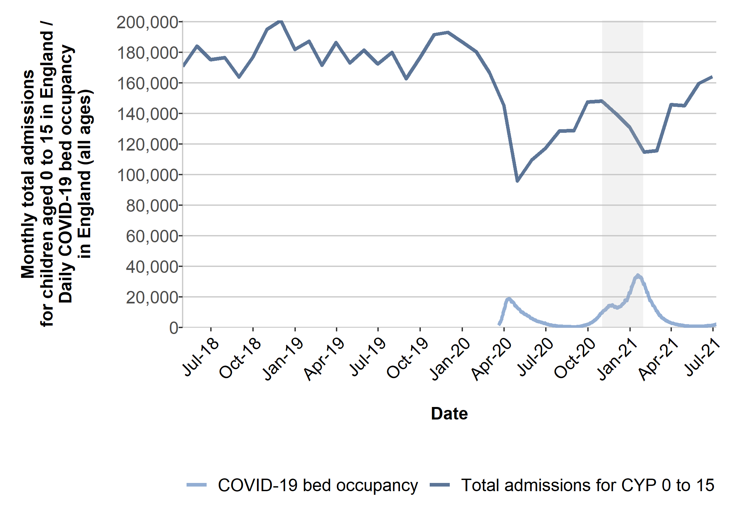
*Grey area shows the sampling period for the 2020 Children and Young People’s Patient Experience Survey (November 2020 – January 2021)
Source: NHS Digital Monthly Provisional Monthly Hospital Episode Statistics for Admitted Patient Care and Outpatients. COVID-19 bed occupancy: gov.uk Coronavirus (COVID-19) in the UK dashboard, https://coronavirus.data.gov.uk/details/healthcare.

Results from the survey
This section presents the results for the 2020 Children and Young People’s Patient Experience Survey. Statistically significant differences between age groups, comparing results for those aged 0 to 7, 8 to 11 and 12 to 15, and survey years are highlighted where possible. We use an asterisk (*) to indicate statistically significant within-year age group differences in tables of results and arrows (↑↓) to indicate statistically significant differences between 2018 and 2020, or 2016 and 2020. Please note that for some questions, comparability is not available across all three survey years due to changes to the question, as detailed in the Survey Development Report.
To understand how patient experience varies between different groups of patients, we have included an additional subgroup analysis in this section. The Equality Act 2010 legally protects people from discrimination when using public services and extends to the family and friends of anyone who has a protected characteristic. The protected characteristics we were able to assess in the survey results include age, sex, disability and ethnicity. We have also assessed differences between people’s experiences by:
- whether the parent or carer completed the children’s questionnaire on behalf of their child
- whether a patient received medical or surgical care while in hospital
- overnight stay (whether the patient was an inpatient or day case)
- the type of ward the patient stayed on (children’s, teenage/adolescent or adult)
- the number of times they stayed in hospital in the past six months
There is a full summary of results in section 9.
Survey results are organised under the following key themes:
1. Admission to hospital
2. Hospital and ward
3. Doctors and nurses
4. Facilities for parents and carers
5. Pain management
6. Operations and procedures
7. Leaving hospital
8. Overall.
Please note, responses to questions such as ‘don't know / can’t remember’ are not shown or included in percentage calculations. Percentages presented in tables and charts are rounded to the nearest whole number.

1. Admission to hospital
The NHS Patient Experience Framework identifies access to care and the time spent waiting to receive care as important elements of patient experience.
Overall, just over six in 10 children and young people’s admissions were emergency admissions (61%) and just under four in 10 were planned (39%). The proportion of emergency admissions overall in 2020 is slightly but statistically significantly lower than in 2018 and 2016 (where the proportion was 63% and 64%, respectively).
Parents and carers of children aged 0 to 7 who told us that their child came to hospital as a planned admission were asked whether the hospital gave them a choice of admission dates. Most parents said ‘no’ (69%), a statistically significant increase compared to both 2016 (64%) and 2018 (66%). Parents and carers were also asked whether the hospital changed their admission date at all. This year, there was a significant decrease in parents answering ‘no’ to this question (81%) compared to 2016 and 2018 (both 83%).
Almost half of parents and carers reported that their child had only been to hospital ‘once’ in the last six months (49%), an increase on 2018 (46%). Figure 2 shows a smaller proportion of children and young people visited the hospital ‘two or three times’ (34%) or ‘four times or more’ (16%) this year, where figures in 2018 were 37% and 18% respectively.
Figure 2. X81: ‘Including this visit, how many times has your child been to hospital in the past six months?’ by year

Note: Respondent numbers. 2020: 0 to 7 (13,876), 8 to 11 (5,842) 12 to 15 (6,996). 2018: 0 to 7 (19,301), 8 to 11 (6,289), 12 to 15 (6,950). Black arrows indicate statistically significant difference.

2. Hospital and ward
Play and activities
The importance of providing children and young people with play and activities is emphasised in Getting the right start: National Service Framework for Children, which states that a variety of play interventions should be delivered at every stage of a child’s care journey. Evidence provided by the Starlight Children’s Foundation suggests that children and young people feel less pain during treatment when they are engaged in play.18 In addition to play, it is a statutory requirement that, for children staying in hospital for a prolonged duration, education services should be offered to help the child’s learning and development.
As a result of enhanced infection prevention and control measures, some play services and activities in hospitals were unavailable during the COVID-19 pandemic, including shared toys and the closure of playrooms and social spaces. To keep children and staff safe, hospitals had to adapt how they kept children entertained and were more likely to provide independent forms of play, including arts and crafts packs or online gaming consoles.18,19
Findings this year suggest that such measures have had an impact on children and young people’s experiences of having enough to do in hospital. Children and young people aged 8 to 15 were asked ‘were there enough things for you to do in the hospital?’. Under half (44%) said ‘yes’, (Figure 3). This is a significantly smaller proportion than in both 2016 (51%) and 2018 (50%). Just over one in five (21%) said ‘no’.
Figure 3. X51: ‘Were there enough things for you to do in the hospital?’ by year

Note: Answered by children and young people aged 8-15 (2020 = 10,879, 2018 = 10,007, 2016 = 10,453). Black arrows indicate statistically significant increase or decrease between 2018 and 2020. Grey arrows indicate statistically significant increase or decrease between 2016 and 2020.

Parents of children aged 0 to 7 were asked whether their child had enough to do in hospital. Figure 4 shows that this year, just over four in 10 said ‘yes, definitely’ (43%); this is compared to over six in 10 in both 2018 (61%) and 2016 (63%). This 18-percentage point change on 2018 is one of the largest year-on-year changes observed by NHS Patient Survey Programme surveys. This finding suggests that the youngest children have been most affected by restrictions on activities.
In contrast, experiences of play with staff are largely unchanged from previous years. Children aged 8 to 11 were asked whether staff played or did any activities with them during their time in hospital. Of those who indicated they wanted to play, only around a quarter (24%) of children said they played ‘a lot’ (Figure 5). The majority of children (41%) who wanted to play while in hospital said this did not happen. These figures are similar to 2018 and 2016.
Parents and carers of children aged 0 to 7 reported more positive experiences of play during their child’s time in hospital, with almost three-quarters (74%) saying staff played with their child. This is a small but statistically significant increase compared to 2018 (73%) but unchanged on 2016 (74%).
Figure 4. X9: ‘Were there enough things for your child to do in the hospital?’ by year

Note: Answered by parents of children aged 0 to 7 (23,283 in 2016, 22,307 in 2018 and 14,671 in 2020). Respondents who answered 'Can’t remember / I did not notice' have been excluded.
Black arrows indicate statistically significant increase or decrease between 2018 and 2020.
Grey arrows indicate statistically significant increase or decrease between 2016 and 2020.

Figure 5. X49: ‘Did hospital staff play with you or do any activities with you while you were in hospital?’

Note: Answered by children aged 8 to 11 years old (2,901). Respondents who answered 'I did not want or need them to' have been excluded.
Getting the right start: National Service Framework for Children states that children should have access to age-appropriate forms of entertainment. Recreational activities such as books, games and toys should be regularly refreshed and updated for children to use. According to the Starlight Foundation Impact of Children’s Play in Hospital report, technology has been at the forefront of children’s entertainment at hospital during the pandemic, with families and children being able to interact online and play games. The charity advocate for the provision of gaming consoles, art kits and boxes of toys to help distract and entertain children during their hospital stay.18
Children and young people aged 8 to 15 who used the hospital Wi-Fi were asked whether it was good enough to do what they wanted. Responses were more positive this year: 47% of children saying ‘yes, always’ compared to 41% in 2018. Just over a third (37%) said ‘yes, sometimes’ and 16% said ‘no’. Similarly, 44% of parents and carers of children aged 0 to 7 said that the Wi-Fi was always good enough for their child to use, a statistically significant increase on 36% in 2018. The NHS Digital Wi-Fi programme recognises the need to improve connectivity to ensure patients can make use of a range of digital services.
Food
Access to healthy and culturally appropriate food and drink is essential for children and young people in hospital, as stated under standard 5 of the WHO Standards for improving the quality of care for children and young adolescents in health facilities. Guidelines by NICE, Babies, children and young people's experience of healthcare, note that food should be healthy and balanced to aid recovery. The availability of food should also be flexible, with snacks available outside of mealtimes. As advised in Getting the right start: National Service Framework for Children, food options should be child-friendly and familiar to help encourage children to eat.
Children and young people aged 8 to 15 were asked whether they liked the hospital food. Overall, 52% said ‘yes’. A slightly smaller proportion of children said ‘no’ this year (15%) compared to 2016 and 2018 (both 17%). Table 1 shows that younger children were more positive about food: 57% of children aged 8 to 11 said ‘yes’ they liked the hospital food, compared to 48% of young people aged 12 to 15.
Table 1. X53: ‘Did you like the hospital food?’ by age
 | Age group |  |  |  | Significant difference between: 8-11 & 12-15
 | 8-11 | 12-15 | 8-15 |  | Significant difference between: 8-11 & 12-15
Yes | 57% | 48% | 52% |  | *
Sort of  No | 31%  13% | 35%  17% | 33%  15% |  | *  *
Note: Answered by children and young people aged 8 to 11 (3,379) and 12 to 15 (4,288). Respondents who answered 'I did not have hospital food' have been excluded.

Analysis of differences by patient group (section 9) showed that children who had cancer in the last 5 years and children with a mental health condition reported worse than average perceptions of hospital food. Children who stayed overnight during their time in hospital and children who visited most frequently (four times or more in the previous six months) also reported worse than average experiences of food.
Parents and carers of children aged 0 to 7 were asked whether their child liked the hospital food; 39% said ‘yes, definitely’; a small but statistically significant increase on 2016 (36%) and 2018 (35%); 43% said ‘yes, to some extent’; and just under one in five (18%) said ‘no’ their child did not like the food provided.
Environment
The hospital environment can have an impact on children and young people’s healthcare experience. According to NICE guidelines, Babies, children and young people's experience of healthcare, an unsuitable ward environment can evoke feelings of anxiety and distress. For children and young people, it is crucial that the hospital environment is clean, comfortable, age appropriate and quiet to help them feel safe.
Wards must provide adaptations to suit the needs of children and their families. This supports the Getting the right start: National Service Framework for Children, which advises that children should not be cared for on an adult ward. Instead, they should be treated on wards appropriate for their age, development, needs and preferences.
Guidelines in the WHO Standards for improving the quality of care for children and young adolescents in health facilities and Department of Health’s You’re Welcome both emphasise the importance of dedicated treatment areas for children and young people that are comforting and welcoming.
Young people aged 12 to 15 were asked whether the ward was suitable for someone their age. Figure 6 shows that children were more positive this year: 76% said ‘yes’, a statistically significant increase on 68% in 2016 and 69% in 2018, 4% said ‘no’, a statistically significant decrease from 8% in 2016 and 7% in 2018.
Figure 6. X50: Was the ward suitable for someone of your age? by year

Note: Answered by young people aged between 12 and 15 years (2020 = 5,965, 2018 = 5,151, 2016 = 5,328).
Black arrows indicate statistically significant increase or decrease between 2018 and 2020.
Grey arrows indicate statistically significant increase or decrease between 2016 and 2020.

Parents and carers of children and young people aged 0 to 15 were asked what type of ward their child stayed on (Figure 7). Overall, 96% said that their child stayed on a children’s ward. Ten per cent of parents of young people aged 12 to 15 reported that their child stayed on an adolescent ward. Ninety-nine per cent of parents of children aged 0 to 7 reported that their child stayed on a children’s ward and 1% reported that their child stayed on an adult ward. The percentage of children and young people staying on a children’s ward has remained consistent, with 97% of parents reporting that their child stayed on a children’s ward in both 2016 and 2018.

Figure 7. X5: ‘For most of their stay in hospital, what type of ward did your child stay on?’ by age

Note: Answered by parents/carers of all age groups (0 to 7 = 16,522, 8 to 11 = 4,337 and 12 to 15 = 5,499).
Table 2 shows that as in 2016 and 2018, young people aged 12 to 15 were more likely to think that the ward was suitable for someone their age if they had stayed on a teenage or adolescent ward. Out of the young people who stayed on a teenage or adolescent ward, almost eight in 10 (79%) said it was suitable for someone their age. This falls to 70% for those who stayed on an adult ward and 76% on a children’s ward.
Table 2. X5: ‘For most of their stay in hospital, what type of ward did your child stay on?’ By X50: ‘Was the ward suitable for someone of your age?’
X50: Was the ward suitable for someone of your age? | X5: For most of their stay in hospital, what type of ward did your child stay on?
X50: Was the ward suitable for someone of your age? |  | A children’s ward | An adult ward | A teenage/adolescent ward
X50: Was the ward suitable for someone of your age? | Yes | 76% | 70% | 79%
X50: Was the ward suitable for someone of your age? | Sort of  No | 20%  4% | 23%  7% | 20%  2%
Note: Percentages of children and young people aged 12 to 15 years who answered X50 (5,965) and whose parents answered X5 (5,499).
Getting the right start: National Service Framework for Children states that clinical equipment must be the correct size and tailored to an individual’s age and development. The hospital environment must also be spacious enough to accommodate the equipment required by children and young people with disabilities.
Parents and carers of all age groups were asked whether the hospital ward had appropriate equipment or adaptions for their child’s physical or medical needs. Overall, 80% of parents said ‘yes, definitely’; a small but significant decrease compared to 2016 and 2018 (both years 82%). ‘Yes, to some extent’ was reported by 16% of parents and carers, and 3% answered ‘no’. Parents of children aged 0 to 7 (82%) and 8 to 11 (81%) were both more likely than parents of young people aged 12 to 15 (75%) to say that ‘yes, definitely’ the ward had the appropriate equipment or adaptations for their child’s need.
Our subgroup analysis revealed that, parents and carers of children who stayed on an adult ward reported poorer than average experiences for ‘respect for their child’s individual needs and preferences’ (including questions on whether they felt staff knew how to care for their child’s needs and the ward had the appropriate equipment or adaptations for their child’s needs).
Evidence shows that poor quality sleep due to noise disruptions has negative consequences for wellbeing and experience of care. Disturbed sleep can also impair wound healing and immunity. The British Medical Association’s report The Psychological and Social Needs of Patients stresses the benefit of quiet hospital environments for patients’ functioning and their recovery from illness. Rest and sleep are highlighted as key considerations in the planning of facilities in NHS Estate’s Improving the patient experience – Friendly healthcare environments for children and young people. NHS England’s Toolkit’s for reducing poor experiences of inpatient care identifies night time disturbance as an area for improvement in the NHS. Guidelines provided by NICE note that inpatient wards that are quiet enough for sleep are vital to providing a suitable care environment for children and young people.
We asked children and young people whether it was quiet enough for them to sleep if they needed to. Of children aged 8 to 15 who needed to sleep during their stay at hospital, just under half (47%) said it was ‘always’ quiet enough (see Figure 8), but this is a statistically significant improvement compared to 2016 and 2018 (both 40%).

Figure 8. X54: ‘Was it quiet enough for you to sleep when needed in the hospital?’ by year

Note: Answered by children and young people aged 8 to 15 (2020 = 7,611, 2018 = 6,846, 2016 = 7,420).
Respondents who answered 'I did not need to sleep in the hospital' have been excluded.
Black arrows indicate statistically significant increase or decrease between 2018 and 2020.
Grey arrows indicate statistically significant increase or decrease between 2016 and 2020.

Privacy
Under the NHS Constitution, patients have the right to privacy and confidentiality. Numerous health guidelines that focus specifically on children’s care, including Babies, children and young people's experience of healthcare issued by NICE, state that privacy and dignity during examinations, treatment and sensitive conversations are crucial for the wellbeing of children and young people in healthcare settings.
We asked children and young people aged 8 to 15 whether they were given enough privacy when receiving care and treatment. Figure 9 shows that most children and young people said ‘yes, always’ (86%) – a statistically significant improvement compared to 2016 and 2018 (both 82%).
Parents and carers of children aged 0 to 7 were asked ‘was your child given enough privacy when receiving care and treatment?’. Almost nine in 10 parents and carers responded ‘yes, always’ (89%); a statistically significant improvement compared to 2016 and 2018 (both 84%) and 1% said ‘no’.

Figure 9. X62: ‘Were you given enough privacy when you were receiving care and treatment?’ by year

Note: Answered by children and young people aged 8 to 15 (2020 = 10,979, 2018 = 10,093, 2016 = 10,520).
Black arrows indicate statistically significant increase or decrease between 2018 and 2020.
Grey arrows indicate statistically significant increase or decrease between 2016 and 2020.

The right to private and confidential conversations with healthcare staff is recognised in the NHS Youth Forum’s Youth Rights in Healthcare. According to NICE guidelines, Babies, children and young people's experience of healthcare, children and young people should be given the opportunity to privately see and talk to a healthcare professional without the presence or involvement of their parent or carer. This echoes You’re Welcome – Quality criteria for young people friendly health services, which states that young people should regularly have opportunities to be seen on their own. However, as recognised in the report, Our Children Deserve Better: Prevention Pays, it can sometimes be difficult for children and young people to speak independently about their care. Research has found that children find it easier to discuss their care and treatment when they form a trusting relationship with the professionals looking after them.12
We asked young people aged 12 to 15 whether, if they wanted to, they were able to talk to a doctor or a nurse without their parent or carer being there. Of those who indicated they wanted to, 92% said ‘yes’ and 8% said no. This is a small but statistically significant improvement on results from 2016 and 2018, where in both years 90% of children and young people said ‘yes’ and 10% said ‘no’.
Cleanliness
We asked all parents and carers how clean they thought the room or ward was that their child stayed in. Figure 10 shows that over three-quarters of parents (77%) said that the environment was ‘very clean’. This is a statistically significant 10 percentage point increase on 2016 and 2018 (both 67%). This finding likely reflects enhanced infection prevention and control measures in children’s services in response to the COVID-19 pandemic.
Figure 10. X7: ‘How clean do you think the hospital room or ward was that your child was in?’ by year

Note: Answered by parents and carers of all age groups (2020 = 26,915, 2018 = 32,475, 2016 = 34,325).
Black arrows indicate statistically significant increase or decrease between 2018 and 2020.
Grey arrows indicate statistically significant increase or decrease between 2016 and 2020.

3. Doctors and nurses
Communication with children and young people
The NHS Patient Experience Framework highlights that communication and education about clinical status, progress and processes of care are important factors in patient experience. According to NICE guideline Babies, children and young people's experience of healthcare, children should be communicated with directly, in a sensitive and age-appropriate manner. You're Welcome – Quality criteria for young people friendly health services requires all staff who are likely to interact with young people to have received training on communicating effectively with them. Getting the Right Start: National Service Framework for Children asks that, to ensure children can participate fully in their care, a range of communication methods should be used to share information with children. This is supported by Standard 8 of the RCPCH’s Facing the Future: Together for child health, which calls for diversity of information formats provided to children and their parents and carers.
Children and young people aged 8 to 15 were asked whether hospital staff spoke with them about how they were going to care for them: 88% said ‘yes’, 10% said ‘sort of’ and 2% said ‘no’.

While most children aged to 8 to 15 (70%) said they ‘always’ understood what hospital staff said when they spoke with them, just over three in 10 (31%) said they did not always understand. These figures are not significantly different from 2016 and 2018. Young people aged 12 to 15 were significantly more likely to ‘always’ understand what staff said (74%) than children aged 8 to 11 (64%). Responses to this question were most negative compared to the other communication question (Figure 11).
Figure 11. X55: ‘Did hospital staff talk with you about how they were going to care for you?’, X56: ‘When the hospital staff spoke with you, did you understand what they said?’, X60: ‘When you spoke to hospital staff, did they listen to what you had to say?’ and X57: ‘Did you feel able to ask staff questions?’
* Response options for X55 are "Yes", "Sort of", "No" and response options for X57 are "Yes", "No". Note: Answered by children and young people aged 8 to 15. Respondents who answered 'Don’t know / can’t remember' have been excluded.
Similarly, 70% of parents and carers of children aged 0 to 7 said staff ‘definitely’ communicated with their child in a way they could understand’. This is a statistically significant improvement from 2016 and 2018 (both 65%). A further 7% said they did not.
As in 2016 and 2018, the majority of children and young people aged 8 to 15 (95%) felt able to ask staff questions. This is a slight, but statistically significant, improvement on 94% in 2016. Just one in 20 (5%) did not feel able to ask questions. Of children and young people who asked questions, 93% said that these were answered – a slight but statistically significant improvement from 92% in 2016 and 2018.
This year children and young people were asked whether, when they spoke to hospital staff, they listened to what they had to say. Figure 11 above shows that most children and young people (85%) said that staff ‘always’ listened to what they had to say.
Our subgroup analysis found that some patient groups felt less positive about the information they received about their care and treatment. This includes, children aged 8 to 11, patients who received medical care, patients who stayed overnight and children with a mental health or neurological condition.
Communication with parents and carers
In addition to communication with children and young people, all parents and carers were asked about how staff had communicated with them. For each question, parents and carers reported better experiences this year than in previous years.
We asked all parents and carers whether they were given information about their child’s care and treatment in a way they could understand. Most parents and carers said ‘yes, definitely’ (86%), which is a statistically significant increase on 2016 and 2018 (both 82%). Parents of children aged 0 to 7 were significantly less likely to say this had definitely happened (84%) than parents of children and young people aged 8 to 11 (90%) and 12 to 15 (89%).
This year, we saw a statistically significant increase in parents and carers who felt ‘definitely’ able to ask staff questions about their child’s care (83%) in comparison to 79% in both 2016 and 2018. This year, 15% said they could ‘to some extent’ and 1% said they couldn’t.
When asked whether hospital staff kept them informed about their child’s care, most (77%) felt this ‘definitely’ happened while 3% said it had not. This is a significant improvement for ‘yes, definitely’ from 2016 and 2018 (both 70%). Parents of children aged 8 to 11 (81%) and 12 to 15 (80%) were significantly more likely to respond ‘yes definitely’ than parents of children aged 0 to 7 (75%).
Parents of children aged 0 to 7 were asked whether different members of staff gave them conflicting information. Seventy-one per cent said ‘no, never’, one in five (20%) said ‘yes, sometimes’ and almost one in 10 (9%) said ‘yes, a lot’. The proportion of parents who said ‘no, never’ (71%) is a significant increase on 66% in both 2016 and 2018.

Figure 12. X22: ‘Did different staff give you conflicting information?’ by year

Note: Answered by parents/carers of children aged 15 days to 7 years (2020 = 16,742, 2018 = 24,353, 2016 = 25,190).
Black arrows indicate statistically significant increase or decrease between 2018 and 2020.
Grey arrows indicate statistically significant increase or decrease between 2016 and 2020.
You're Welcome – Quality criteria for young people friendly health services and NICE guidelines, Babies, children and young people's experience of healthcare, require staff to introduce themselves to children and young people and explain who they are. The Hello my name is… campaign emphasises how a simple introduction can be a crucial first step towards a positive therapeutic relationship between a patient and health care professional.
Parents and carers of children aged 0 to 7 were asked whether new members of staff treating their child introduced themselves. Most (85%) said ‘yes, always’, 13% said ‘yes, sometimes’ and 2% said ‘no’. Experiences were significantly more positive this year than in 2016 and 2018 where the proportion who answered ‘yes, always’ was lower at 80% and 79%, respectively.
Involvement
Research shows that children report better experiences of healthcare if they form trusting relationships with the staff caring for them and are involved in discussions and decisions about their care.13
NICE guidelines, Babies, children and young people's experience of healthcare, state healthcare professionals should involve children and young people in decisions about their care in ways that consider their maturity and understanding. A child’s right to be involved in decisions about their care is recognised in Getting the Right Start: National Service Framework for Children under Article 12 of the UN Convention for the Rights of the Child.
The proportion of children and young people reporting that they were involved in decisions about their care and treatment was consistent with 2018 but was slightly improved on 2016. Of those who indicated they wanted to be involved, 46% said they were involved ‘a lot’ (compared with 46% in 2018 and 43% in 2016), and 14% said they were not (compared with 15% in 2018 and 16% in 2016).
Figure 13. Response percentages for X59: ‘Were you involved in decisions about your care and treatment?’

Note: Answered by children and young people aged 8 to 15 (10,144).
Respondents who answered 'I did not want to be involved' have been excluded.

As part of the subgroup analysis, we assessed whether children felt their own needs and preferences were taken into consideration, using questions about their involvement in decision making and the level of privacy they were given. We found that, children in the following groups reported poorer than average experiences: children aged 8 to 11, children in the 9th and 10th (least deprived) Index of Multiple Deprivation (IMD) decile, patients treated under medical care, children who stayed overnight and children with a mental health condition.
We asked parents and carers three questions about their involvement in their child’s care. The majority of all parents (93%) said that staff agreed a plan for their child’s care with them, 7% said they did not.
When asked whether staff involved them in decisions about their child’s care and treatment, almost three-quarters of parents (74%) said ‘yes, definitely’, 21% said ‘yes, to some extent’ and 4% said ‘no’.
Eight in 10 parents (80%) said they were ‘definitely’ given enough information to be involved in decision making. This is a statistically significant improvement compared to 2016 and 2018 (both 76%).
The subgroup analysis revealed that, parents of younger children (aged 0 to 7), parents of children who received medical care, had stayed at hospital in the previous six months or who had a mental health condition, reported poorer than average experiences of feeing involved in their child’s care.

Knowledge
We asked all parents and carers of children aged 0 to 15 ‘Were the different members of staff caring for and treating your child aware of their medical history?’. Although the majority responded ‘yes, definitely’ (61%), just under a third of parents (32%) felt that members of staff knew their child’s medical history only ‘to some extent’. These results are small but statistically significant improvements from 2016 and 2018. As in previous years, parents of children aged 0 to 7 reported more negative experiences compared to the other age groups (Table 3).
All parents were also asked whether staff looking after their child knew how to care for their needs. Most parents said ‘yes’ (79%), 19% said ‘yes, to some extent’ and 3% said ‘no’.
Table 3. X23: ‘Were the different members of staff caring for and treating your child aware of their medical history?’ by age
 | Age group |  |  |  |  | Significant difference between:
 | 0-7 | 8-11 | 12-15 | 0-15 |  | 0-7 &  8-11 | 0-7 &  12-15 | 8-11 & 12-15
Yes, definitely | 57% | 68% | 67% | 61% |  | * | *
Yes, to some extent | 35% | 27% | 28% | 32% |  | * | *
No | 8% | 5% | 5% | 7% |  | * | *
Note: Answered by parents/carers of all age groups (0 to 7 = 14,743, 8 to 11 = 4,025, 12 to 15 = 5,092).
Respondents who answered 'Don't know / not applicable' have been excluded.

Support
The NHS Patient Experience Framework highlights emotional support and the alleviation of worries and fear as key aspects of patient experience. NICE guidelines, Babies, children and young people's experience of healthcare recognise that for children and young people, visiting hospital can be particularly worrying and distressing. Specific support is required to help younger patients feel reassured and comfortable. Feedback from children and young people as part of RCPCH’s Being me - supporting children and young people campaign, calls for doctors and nurses to be kind, get to know patients, and talk with them about any worries or concerns.
We asked children and young people aged 8 to 15, ‘If you had any worries, did a member of staff talk with you about them?’. Experiences were slightly more positive this year. Of the children and young people who had worries and wanted to discuss them with staff, the majority (94%) said ‘yes’ (up from 92% in 2018) and 6% said ‘no’ (down from 8% in 2018).

Availability and teamwork
The National Quality Board’s Safe, sustainable and productive staffing: An improvement resource for children and young people’s inpatient wards in acute hospitals states that ‘children and young people’s inpatient wards must have sufficient and appropriate staffing capacity and capability to provide safe, high-quality and cost-effective care at all times’. The Royal College of Nursing’s Defining staffing levels for children and young people’s services set out the numbers of nurses expected for each patient for both general and specialist children’s wards, including a minimum of two registered children’s nurses in inpatient and day case areas, and increasing staff to patient ratios.
Many hospitals have adapted the way they resource different types of care since the beginning of the COVID-19 pandemic. Guidelines, including Redeploying your secondary care medical workforce safely, advised that, where necessary, community paediatric doctors with acute experience should be redeployed to support children’s emergency services. Alternatively, where paediatric wards had enough resource, trusts were advised to consider redeploying staff to adult critical care. The RCPCH found that during the second wave of COVID-19, 13% of services redeployed paediatric consultants to adult services due to increased demand. 21,22
All parents and carers were asked whether members of staff were available when their child needed attention. Almost three-quarters of parents (74%) said staff were ‘always’ available. Figure 14 shows that experiences are significantly improved on 2016 and 2018.
Figure 14. X25: ‘Were members of staff available when your child needed attention?’ by year

Note: Answered by parents and carers of all age groups, (2020 = 25,971, 2018 = 31,137, 2016 = 32,920).
Black arrows indicate statistically significant increase or decrease between 2018 and 2020.
Grey arrows indicate statistically significant increase or decrease between 2016 and 2020.
Overall, over eight in 10 parents and carers (83%) said that staff ‘definitely’ worked well together. Responses to this question are more positive this year compared to 2016 and 2018, where in both years, 76% answered ‘yes, definitely’. Parents were also asked whether they had confidence and trust in the members of staff who treated their child. Overall, 84% of parents said ‘yes, always’. Parents were more positive this year than in 2016 and 2018, where 79% and 80% of parents respectively said they ‘always’ had confidence and trust in staff.
Raising concerns
The NHS Constitution gives both patients and staff the right to raise complaints or concerns and have their complaints or concerns addressed promptly. The constitution also pledges that staff should aim to be open, welcoming and listen to feedback from patients and their families. CQC research suggests that many people who have concerns about their health and social care do not raise them. CQC’s Declare Your Care campaign is encouraging people to speak up about their care experiences.
We asked parents and carers of children aged 0 to 15 ‘If you had been unhappy with your child’s care and treatment, do you feel that you could have told hospital staff?’. Parents were slightly more positive this year: just over two-thirds of parents (67%) said ‘yes, always’, which is a significant increase on 64% in 2018. Table 4 shows that parents of children aged 0 to 7 were significantly less likely to give the most positive response compared to parents of older age groups.
Table 4. X27: ‘If you had been unhappy with your child’s care and treatment, do you feel that you could have told hospital staff?’ by age
 | Age group |  |  |  |  | Significant difference between:
 | 0-7 | 8-11 | 12-15 | 0-15 |  | 0-7 &  8-11 | 0-7 &  12-15 | 8-11 & 12-15
Yes, always | 64% | 72% | 73% | 67% |  | * | *
Yes, sometimes | 25% | 21% | 20% | 23% |  | * | *
No | 11% | 7% | 6% | 9% |  | * | *
Note: Answered by parents/carers of all age groups (0 to 7 = 16,782, 8 to 11 = 4,422, 12 to 15 = 5,738).

Subgroup analysis (see section 9) showed that parents and carers of Asian or Asian British children reported more negative experiences of raising concerns with members of staff. Parents of White children reported above average experiences in this area.

4. Facilities for parents and carers
Getting the Right Start: The National Service Framework for Children states that hospitals should provide facilities for patients’ parents and siblings, including overnight facilities, and that they should be able to access meals. Standard 8 of the WHO Standards for improving the quality of care for children and young adolescents in health facilities also states that parents or caregivers should be able to stay with their children and sleep, wash, and cook.
Since the beginning of the COVID-19 pandemic, access to some facilities in English hospitals have been adapted to prevent and control infection. In line with government policy, cafés, restaurants and some shops on hospital sites were closed during local or national lockdowns. Limits were also placed on visitation, communal food preparation and hot drink facilities.
We asked all parents and carers whether they had access to hot drinks facilities in hospital. Likely due to closures and limits on access to communal areas, Figure 15 shows a large statistically significant drop in parents accessing a kitchen area/parents’ room; 28% of parents in 2020 compared to 54% in 2016 and 2018. Similarly, fewer parents used other hot drinks facilities, such as vending machines. In contrast, almost half of parents and carers (48%) said ‘I was offered drinks by members of staff’, which is a significant increase on 23% in 2016 and 2018.
Figure 15. Response percentages for X29: ‘Did you have access to hot drinks facilities in the hospital?’

Note: Answered by parents/carers of all age groups (2020 = 26,601, 2018 = 32,225, 2016 = 33,420).
Multiple response question.

Similarly, parents and carers of children of all ages were asked whether they were able to prepare food in the hospital. Out of those who indicated they wanted to, the majority said ‘no’ (61%) – a statistically significant 25 percentage point increase on 36% in 2018. Just under a quarter (22%) said ‘yes, definitely’.
Due to concerns around the implementation of COVID-19 visitation restrictions, this year we asked parents whether they were able to be with their child as much as they needed to be during their time in hospital. Most parents (95%) said they were ‘definitely’ or ‘always’ able to be with their child.

5. Pain management
Correctly identifying and managing pain is identified as an area for improvement in children’s hospital care in Getting the Right Start: National Service Framework for Children. The You’re Welcome – Quality criteria for young people friendly health services states that when managing pain, children and young people should be provided with information to help involve them in decisions regarding pain relief management. Likewise, patients should be informed about the different treatment options.
This is reinforced by the NICE Babies, children and young people's experience of healthcare guidelines, which express the importance of being honest with children about the possible pain associated with treatments or procedures. Distractions are particularly important, since research shows that children engaged in play feel less pain during treatment. The College of Emergency Medicine’s best practice guidelines, Management of Pain in Children, recommends that, from the start of a care journey and throughout, pain management should be a priority.
We asked children and young people aged 8 to 15, ‘If you felt pain while you were at the hospital, do you think staff did everything they could to help you?’. Overall, 82% said ‘yes’, which is a small but statistically significant increase on 80% in 2016 and 79% in 2018. This means that almost one in five (18%) children did not feel that staff did everything they could to manage their pain,14% said ‘sort of’ and 4% said ‘no’.
Parents’ perceptions of pain management were similar. Just under eight out of 10 parents and carers of children aged 0 to 15 (78%) said staff ‘definitely’ did everything they could to help if their child felt pain. Almost one in five (18%) said ‘yes, to some extent’.
Figure 16. X64: ‘If you felt pain while you were in the hospital, do you think staff did everything they could to help you?’

Note: Answered by children and young people aged 8-15 (2020 = 8753, 2018 = 8119, 2016 = 8,513). Respondents who answered 'I did not feel any pain' have been excluded.

6. Operations and procedures
The Royal College of Surgeons’ Standards for Children’s Surgery recommends that both the child and their family are involved in the decision to operate. Staff should regularly communicate with parents about their child’s care, and the information provided should be clear for parents to understand. Children and young people should also be provided with information, verbally or through the use of leaflets. The Royal College of Nursing Day Surgery for Children and Young People states that keeping the patient and their family well informed is crucial for achieving positive treatment outcomes.
Children and families should be able to discuss treatment options, findings, recovery timescales, and complications. The WHO’s Standards for improving the quality of care for children and young adolescents in health facilities states that children and their families should be informed about proposed investigations, the risks and benefits, and that consent should be sought for procedures. Getting the Right Start: National Service Framework for Children says that communication and information is especially important when a procedure is unpleasant or painful. This is supported by NICE guidelines, Babies, children and young people's experience of healthcare, which advise staff to be honest with children and their families about potential pain or discomfort associated with a procedure or treatment.
Children and young people who had an operation or procedure were asked a set of questions about their experience. The majority of children (93%) reported that, before the operation of procedure, staff explained to them what would be done. Just over one in twenty (6%) said it was ‘sort of’ explained and 1% said it was not.
Children and young people were also asked whether staff explained to them afterwards how the procedure or operation went. Figure 17 shows that responses were less positive for this question, with 80% saying ‘yes’, 14% saying ‘sort of’ and 5% saying ‘no’. Young people aged 8 to 11 reported significantly fewer positive experiences (77%) than children aged 12 to 15 (83%).
Overall, most parents (91%) whose child had an operation or procedure said that staff ‘completely’ answered their questions beforehand. Less than one in 10 (8%) said that their questions were answered ‘to some extent’ and 1% said their questions were not answered in a way they could understand.
Distracting children with play during operations and procedures is recommended by the Royal College of Surgeons. Evidence shows that children feel less pain during treatment when they are engaged in play. Getting the Right Start: National Service Framework for Children highlights the positive effects of play on children’s ability to cope with procedures and interventions. This is supported by NICE guidelines, advising that ‘therapeutic play and distraction techniques’ are used to create ‘a calm environment’ before, during and after interventions or procedures.
All parents were asked whether, during any operations or procedures, staff played with their child or distracted them. Almost two-thirds of parents (65%) said ‘yes, definitely’, just under a quarter (23%) said ‘yes, to some extent’ and over one in 10 (12%) said ‘no’. Respondents who answered 'It was not necessary' have been excluded.
Figure 17. X66: ‘Before the operations or procedures, did hospital staff explain to you what would be done?’ and X67: ‘Afterwards, did staff explain to you how the operations or procedures had gone?’

Note: Answered by children and young people aged 8 to 15 (X66 = 5,881, X67 = 5,851) who have had an operation or procedure. Filtered question.

7. Leaving hospital
Getting the Right Start: National Service Framework for Children states that, at the end of a hospital stay, children, young people and their parents should be given information about the possible side effects of treatments, any further treatment that may be required and implications for school attendance. A point of contact should be provided in case of future difficulties. The Royal College of Surgeon’s Standards for Children’s Surgery asks that patients and their families receive clear information on discharge and that they are able to contact a health professional for support after leaving the hospital. Facing the Future: Standards for children in emergency care settings, states discharge information should be easy to understand and available in accessible formats. The Department of Health and Social Care’s Ready to Go? Planning the discharge and the transfer of patients from hospital and intermediate care highlights the importance of communication with patients and their families before they leave the hospital, as well as their involvement in and agreement on decisions about their departure.
As displayed in Figure 18, children and young people aged 8 to 15 were asked three questions about their experience of leaving hospital, specifically on whether they received useful information for when they were at home.

Figure 18. X68: ‘Did a member of staff tell you who to talk to if you were worried about anything when you got home?’, X70: ‘Did a member of staff give you advice on how to look after yourself after you went home?’ and X69: ‘When you left hospital, did you know what was going to happen next with your care?’
Note: Answered by children and young people aged 8 to 15. Respondents who answered 'Don’t know / can’t remember' have been excluded.
Almost three-quarters (73%) of children said that staff told them who to talk to if they were worried about anything when they got home. Just under eight in 10 (79%) children said that they were given advice about how to care for themselves when they got home, and 68% said they knew what was going to happen next with their care. These figures remain consistent with 2016 and 2018.
Parents and carers were asked a similar set of questions on information when leaving hospital. Just under one in eight (79%) parents of children aged 0 to 7 said they were told who to talk to if they were worried about their child when they got home. Most parents of children aged 0 to 15 (80%) said that they were given advice about how to care for their child when they got home, which is a statistically significant increase on 2016 (76%) and 2018 (78%). Similarly, 81% of parents said they were given written information about their child’s condition or treatment to take home.
Less than three-quarters (72%) said that they ‘definitely’ knew what was going to happen next with their child’s care, 22% said they knew to ‘some extent’ and 6% said ‘no’. Parents of children aged 8 to 11 were somewhat more likely to answer ‘yes, definitely’ than parents of children aged 0 to 7 or 12 to 15 (see Table 5).

Table 5. X41: ‘When you left hospital, did you know what was going to happen next with your child’s care?’
 | Age group |  |  |  |  | Significant difference between:
 | 0-7 | 8-11 | 12-15 | 0-15 |  | 0-7 &  8-11 | 0-7 &  12-15 | 8-11 & 12-15
Yes, definitely | 71% | 75% | 70% | 72% |  | * |  | *
Yes, to some extent | 22% | 20% | 24% | 22% |  | * | * | *
No | 7% | 5% | 6% | 6% |  | * | *
Note: Answered by parents and carers of all age groups (0 to 7 = 15, 689, 8 to 11 = 4,248, 12 to 15 = 5,494). Respondents who answered 'It was not necessary' have been excluded.

8. Overall
Most children and young people aged 8 to 15 were positive about their care. More than nine in 10 (93%) said that they were looked after either ‘very well’ (73%), which is a small but statistically significant increase on 2016 and 2018 (both 70%), or ‘quite well’ (20%) in hospital. Figure 19 shows, 6% said they were looked after ‘ok’, 1% said ‘quite badly’ and fewer than 1% answered ‘very badly’.
Almost nine in 10 (89%) children said that staff looking after them were ‘always’ friendly, which is a small but statistically significant increase on 2016 and 2018 (both 87%). Only 10% said ‘sometimes’ and 1% said staff were not friendly.
Parents and carers were also positive about their child’s care overall. Parents of children aged 0 to 7 were asked ‘Do you feel that your child was well looked after by the hospital staff?’; 87% said ‘yes always’, 11% said ‘yes, sometimes’ and 2% said no. Results from this question have improved, with significantly more parents reporting ‘yes, always’ compared to 2016 (83%) and 2018 (82%). Similarly, 86% said that the staff looking after their child were ‘always’ friendly, 13% said staff were ‘sometimes’ friendly and 1% said they were not.
Parents were slightly less positive about their own experience. We asked all parents and carers ‘Do you feel that you (the parent/carer) were well looked after by hospital staff?’. Just under three-quarters (74%) said ‘yes, always’, over one in five (21%) said ‘yes, sometimes’ and 5% said ‘no’. Positive responses to this question have significantly increased compared to 2016 and 2018 (67% ‘yes, always’). Parents of children aged 8 to 11 and 12 to 15 were more likely to say they were ‘always’ looked after (79% and 78% respectively) than parents of children aged 0 to 7 (71%).

Figure 19. Response percentages for X72: ‘Overall, how well do you think you were looked after in hospital?’ by age

Note: Answered by children and young people aged 8 to 15 years (8 to 11 = 4,796, 12 to 15 = 6,221, total 8 to 15 = 11,071)

We asked all parents and carers to rate their child’s care overall, on a scale from 0 ‘I felt that my child had a very poor experience’ to 10 ‘I felt that my child had a very good experience’. The majority (85%) rated their child’s experience an eight or above. Figure 20 shows that there were statistically significant increases in the most positive response (10) to the parents’ rating question this year compared to 2016 and 2018.
All parents and carers were asked whether they were treated with dignity and respect by the people looking after their child. Nine in 10 (90%) said ‘yes, always’. Parents of children aged 0 to 7 reported small, but statistically significant improvements this year from 85% in 2016 and 2018 to 88% this year.

Figure 20. X48: ‘Overall… I felt that my child had a very poor experience (0) to I felt that my child had a very good experience (10)’ by year

Note: Answered by parents/carers of all age groups (2020 = 26,515, 2018 = 32,184, 2016 = 33,647)

9. How experience varies for different patient groups: subgroup analysis summary
We have included additional analysis to compare how different groups of patients rated their hospital experiences. Using a ‘multi-level model’, we have compared different groups’ mean scores for a subset of questions. This technique takes account of interdependencies between variables.
There is separate subgroup analysis for children and young people aged 8 to 15 and for parents and carers of children and young people aged 0 to 15. The following themes were assessed, with most based on the Patient Experience Framework.
Children and young people aged 8 to 15:
Information, communication and education
- X55: Did hospital staff talk with you about how they were going to care for you?
- X56: When the hospital staff spoke with you, did you understand what they said?
- X58: Did the hospital staff answer your questions?
- X60: When you spoke to hospital staff, did they listen to what you had to say?
Transition and continuity
- X69: When you left hospital, did you know what was going to happen next with your care?
- X70: Did a member of staff give you advice on how to look after yourself after you went home?
Respect for patient centred values, preferences and expressed needs
- X59: Were you involved in decisions about your care and treatment?
- X62: Were you given enough privacy when you were receiving care and treatment?
Individual questions
- X53: Did you like the hospital food?
- X51: Were there enough things for you to do in the hospital?
- X61: If you had any worries, did a member of staff talk with you about them?
- X72: Overall, how well do you think you were looked after in hospital?

Parents and carers of children and young people aged 0 to 15:
Welcoming the involvement of family and friends
- X16: Did a member of staff agree a plan for your child’s care with you?
- X18: Did staff involve you in decisions about your child’s care and treatment?
- X21: Were you able to ask staff any questions you had about your child’s care?
Individual preferences and needs
- X24: Did you feel that staff looking after you and your child knew how to care for their needs?
- X6: Did the ward where your child stayed have appropriate equipment or adaptations for your child’s physical or medical needs?
Individual questions
- X17: Did you have confidence and trust in the members of staff treating your child?
- X47: Were you treated with dignity and respect by the people looking after your child?
- X23: Were the different members of staff caring for and treating your child aware of their medical history?
- X27: If you had been unhappy with your child’s care and treatment, do you feel that you could have told hospital staff?
- X46: Do you feel that you (the parent/carer) were well looked after by hospital staff?
- X48: Overall… I felt that my child had a very poor experience (0) to I felt that my child had a very good experience (10)

For a table that maps scored question IDs (for example, X55) to question text and question numbers in each of the three questionnaires please see the Question Mapping document. See the detailed charts for the subgroup analyses in Appendix F.
The tables overleaf illustrate the results of the subgroup analysis for children and young people aged 8 to 15, and parents and carers of children and young people aged 0 to 15. Findings significantly above or below average are marked for each subgroup category under each theme.
For more information about the subgroup analysis, criteria for noteworthy subgroup differences, and methodology see the Survey methodology section.
Subgroup analysis results: Children and Young People
The following results demonstrate the findings of the subgroup analysis for children aged 8 to 15. Please note, no significant results were found for the COVID-19 diagnosis or treatment variables, thus these are not included in the summary below. Please see Appendix F for the full charts.
 | Information | Activities | Food | Respect | Transition | Worries | Overall
Age
8 to 11 | W |  | B | W | W
12 to 15 | B |  | W | B | B
Gender
Female / girl
Male/ boy
Other (gender)
Don't want to say
Ethnicity
White |  |  |  |  |  |  | B
Multiple ethnic groups
Asian or Asian British |  |  |  |  |  |  | W
Black or Black British
Arab or other ethnic group
Not known
Treatment function code
Medical | W | W |  | W | W |  | W
Surgical | B | B |  | B | B |  | B
IMD decile
1 (most deprived) |  |  |  | B
2
3
4
5
6
7
8
9 |  |  |  | W
10 (least deprived) |  |  |  | W
Length of stay
No overnight | B | W | B | B
Overnight | W | B | W | W
(continued) | Information | Activities | Food | Respect | Transition | Worries | Overall
Hospital stays in the last six months
Once |  |  | B |  |  |  | B
Two or three times
Four times or more |  |  | W |  |  |  | W
Type of ward stayed on
A children's ward |  | B
An adult ward |  | W
A teenage / adolescent ward |  | B
Proxy response
Child / young person | W |  |  | W | W
Parent / carer | B |  |  | B | B
Both young person & parent / carer together |  |  |  |  | B
Long-term conditions
No blood disorder
Bowel condition, such as Crohn's disease
Breathing problem, such as asthma
Blindness or partial sight
Cancer in the last 5 years |  |  | W
Chromosomal condition, such as Down's syndrome
Deafness or hearing loss
Developmental disability, such as ASD
Diabetes |  |  |  |  | B
Heart problem
Joint problem
Kidney or liver disease
Learning disability
Mental health condition | W |  | W | W | W |  | W
Neurological condition, such as epilepsy | W
Another long-term condition

Subgroup analysis results: Parents of Children and Young People
The following results demonstrate the findings of the subgroup analysis for parents of children aged 0 to 15. Please note, no significant results were found for the COVID-19 diagnosis or treatment variables, thus these are not included in the summary below. Please see Appendix F for the full charts.
 | Concerns | Confidence | Dignity | Involvement | Medical History | Looked after | Preferences | Overall
Age
0 to 7 | W | W | W | W | W | W | W | W
8 to 11 | B | B | B | B | B | B | B
12 to 15 | B | B | B | B | B | B | W
Gender
Female / girl
Male / boy
Other (gender)
Don't want to say
Ethnicity
White | B |  |  |  |  |  |  | B
Multiple ethnic groups
Asian or Asian British | W
Black or Black British
Arab or other ethnic group
Not known
Treatment function code
Medical | W | W | W | W | W | W | W | W
Surgical | B | B | B | B | B | B | B | B
IMD decile
1 (most deprived) |  |  |  |  | B
2 |  |  |  |  | B
3
4
5
6
7
8
9
10 (least deprived) |  |  |  |  | W
(continued) | Concerns | Confidence | Dignity | Involvement | Medical History | Looked after | Preferences | Overall
Length of stay
No overnight |  | B | B | B |  | B |  | B
Overnight |  | W | W | W |  | W |  | W
Hospital stays in the last six months
Once | B | B | B | B | B | B | B | B
Two or three times | W |  |  |  | W
Four times or more |  | W | W | W | W | W | W | W
Type of ward stayed on
A children's ward |  |  |  |  |  |  | B
An adult ward |  |  |  |  |  |  | W
A teenage ward
Long-term conditions
No blood disorder
Bowel condition, such as Crohn's disease
Breathing problem, such as asthma |  |  |  |  | W
Blindness or partial sight
Cancer in the last 5 years
Chromosomal condition, such as Down's syndrome
Deafness or hearing loss
Developmental disability, such as ASD |  |  | W |  | W |  | W | W
Diabetes
Heart problem
Joint problem
Kidney or liver disease
Learning disability
Mental health condition |  | W | W | W | W | W | W | W
Neurological condition, such as epilepsy |  |  |  |  |  |  | W
Another long-term condition |  |  |  |  | W |  | W | W

Survey methodology
The 2020 Children and Young People’s Patient Experience Survey used a postal methodology. Each sampled patient received a maximum of three mailings. A paper questionnaire was sent in both an initial mailing and a second reminder mailing.
Patients aged 15 days to 15 years at the time of discharge were eligible to participate in the survey. The survey sample did not include babies aged 0 to 14 days to reduce the likelihood of including ‘well babies’ who were born in an NHS trust and whose mothers had been the patient.
Trusts were required to draw a stratified sample of up to 1,250 eligible patients from their records who attended hospital as an inpatient or day case and were discharged during November and December 2020 and January 2021. This year, we extended the sampling period by one month, to include January 2021. This is because, due to the decrease in admissions during the second peak of COVID-19, less children attended hospital during November and December compared to usual. To ensure all trusts had enough patients to participate, trusts were asked to also sample from January 2021.
Sample size targets were set at 450 for patients aged 0 to 7 and 400 each for those aged 8 to 11 and 12 to 15. The slightly higher target for those aged 0 to 7 reflects a lower average response rate for this group in the previous iterations of the survey. The target for the 8 to 11 and 12 to 15 was to oversample these age groups to allow analysis at a trust level. Any trust unable to meet the sampling targets was permitted to ‘top-up’ with eligible patients from any other age group, where possible. The possible over-representation of those aged 8 to 15 in the national results has been accounted for within the weighting method applied.
Full details of the sampling are available in the instruction manual for the survey (see the links in Appendix E).
Eligible trusts were those that provided acute hospital care to sufficient numbers of children and young people to draw a sample. No trusts were excluded from the survey.
Fieldwork for the survey (the time during which questionnaires were sent out and returned) took place between March and July 2021.

Analysis methodology
Weighting
We used a two-stage weighting approach to:
- account for the over-sampling of children and young people aged 8 to 15
- to aggregate trust-level data to national level.
The first element is referred to as the ‘population weight’, where trust responses were weighted to reproduce the population age structure for that trust. This ensures that the responses from those aged 0 to 7, 8 to 11 and 12 to 15 have the appropriate influence on national results to reflect the numbers of children within each age group admitted to hospital. The second element of the weighting is referred to as the ‘trust weight’ and has been calculated to give each participating trust an equal influence within national results, regardless of differences in response rates between trusts. Both sets of weights are then multiplied together to produce a single combined weight for the data tables that underpin the analysis.
Rounding
Because tables present percentage figures rounded to the nearest whole number response percentages may not add up to 100%.
Statistical significance
Statistical tests were carried out on the data to determine whether there were any statistically significant differences between ages, where a question was asked across multiple questionnaires, and years, where a question was asked in 2018.
We used a ‘z-test’ to compare data for different age groups at the 95% confidence level. A statistically significant difference means it is very unlikely that we would have obtained this result if there was no real difference.

Subgroup analysis
In this report, subgroup differences are highlighted where a demographic or care characteristic overall (e.g. age) is significantly associated with experience and where the estimated marginal mean for the specific subgroup (e.g. 8 to 11 year olds) is significantly different from the overall mean. For further technical information on the subgroup analysis please see the Quality and Methodology report.

Design and interpretation of the questionnaire
An external advisory group ensured that a wide range of stakeholders had the opportunity to contribute to the development of this survey. Members included representatives from CQC, the Department of Health and Social Care, NHS England, NHS Youth Forum, specialist and non-specialist NHS acute trusts, and charities.
Three new questions were added to the 2020 questionnaires, to gather information about visitation, listening and transitioning to adult services. No questions were removed but some questions were modified. New questions and questions that were modified will not be comparable to 2016 and 2018. For full details, please see the Survey Development Report.

Appendix A: Comparisons with other data
Although there are a variety of national surveys which ask children about different aspects of their lives, there are currently no other national surveys of children and young people’s hospital experiences which we can directly compare to the results of the 2020 Children and Young People’s Patient Experience Survey. The Under 16 Cancer Patient Experience Survey, conducted by NHS England and NHS Improvement in collaboration with Picker Institute, offers some similar insight. The survey examines the experiences of children and young people under the age of 16 receiving treatment for cancer or tumours.
Globally, The Bureau of Health Information in Australia conducts an Admitted Children and Young Patients Survey every three years, but the scope of this survey is more limited than CQC’s Children and Young People’s Survey, as it is restricted to the experiences of only three specialist children’s hospitals. In the United States, the Child Hospital Survey assesses the experiences of children’s and their guardian’s experience of inpatient care. However, due to differences in the methodological approach and reporting of the survey, comparisons are limited.
Comparison with the Under 16 Cancer Patient Experience Survey
The Under 16 Cancer Patient Experience Survey, published in October 2021, collects data from parents of children aged 0 to 7, children aged 8 to 15 and their parents about their/their child’s experiences of cancer or tumour care. The sampling period for this survey was between January 1st and December 31st 2020. Children included in the survey were those with a confirmed cancer or tumour diagnosis who received inpatient or day case care at an NHS Principal Treatment Centre during the sampling period. In contrast, the 2020 Children and Young People’s Survey includes children admitted to hospital for almost any reason, including but not exclusive to, cancer care.
Please note that, whilst some of the methods and themes are similar across each of the surveys, due to key differences in the eligibility criteria and methodology of the Under 16 Cancer Patient Experience Survey, it is difficult to directly compare the results.
Healthcare staff
The percentage of children aged 8 to 15 in both surveys who said that staff looking after them were ‘always’ friendly was the same – 89%. A similar proportion of parents across both surveys said they always had confidence and trust in the staff treating their child (84% for the 2020 Children’s Survey, and 85% for the Under 16’s Cancer Survey).
Over two thirds of parents (70%) in the Under 16s Cancer Survey said that hospital staff always worked well together. In the 2020 Children and Young People’s Survey, 83% of parents said that staff ‘definitely’ worked well together. Just under three quarters (71%) of parents in the CQC survey said that they were ‘never’ given conflicting information from different members of staff. This figure was lower (64%) for the Under 16s Cancer Survey.
The hospital ward
A similar proportion of parents of children aged 0 to 7 felt that there were enough things to do in hospital (43% in the CQC survey, and 45% in the Under 16s Cancer survey). Parents in both surveys rated overnight facilities poorly; 35% of parents in the Under 16s Cancer survey said that facilities were ‘very good’. A similar response of 34% was found in the CQC survey.
Information and communication
Both surveys asked questions about information and communication between patients, their parents and staff. In the Under 16 Cancer Patient Experience survey, 82% of parents/carers of children said they were definitely able to have questions answered after their diagnosis and 70% of parents and carers of children aged 0 to 7 were given information about their diagnosis in a way they could understand. The 2020 Children and Young People’s Survey found that 95% of children felt able to ask staff questions, and of those who asked questions, 93% said that staff answered their questions. Similarly, 86% of parents said that staff ‘definitely’ provided them with information about their child’s care in a way they could understand.
Involvement in decision making
The Under 16s Cancer survey found that 68% of parents felt they were ‘definitely’ involved in decisions about their child’s care and treatment. In CQC 2020 Children’s survey, less than three quarters (74%) of parents felt ‘definitely’ involved with decisions about their child’s care.
Overall
In the Under 16 Cancer survey, 80% of children said they were looked after very well by healthcare staff and 92% of parents rated the overall experience of their child’s care as 8 or more out of 10. For the 2020 Children and Young People’s survey, we found that 73% of children felt ‘very well’ looked after and 85% of parents rated their child’s experience 8 or more out of 10.

Appendix B: Main users of the survey data
This appendix lists known users of data from the Children and Young People’s Survey and how they use the data. We have been reviewing the use of all survey data to identify who uses it. We would like to hear from anyone interested in, or already using, data to contact us with feedback or recommendations at: patient.survey@cqc.org.uk.
NHS trusts and commissioners
Trusts, and those who commission services, use the results to help identify and make the improvements they need to improve the experience of people who use their services. CQC publishes the survey results for each participating NHS trust.
Care Quality Commission (CQC)
CQC uses the results from the survey in the regulation, monitoring and inspection of NHS trusts in England. Survey data is used in CQC’s monitoring tools, which provides inspectors with an assessment of how trusts are performing, with survey data providing the patients’ perspective on this. The survey data will also be used to inform our inspections and as a key source of evidence to support the judgements and ratings for trusts.
NHS England and NHS Improvement
NHS England and NHS Improvement are a key user of data from the NHS Patient Survey Programme. Listening to patients’ experiences of their care plays a crucial part in delivering services that are safe, effective and continuously improving. Data from the survey programme is important for NHS England and Improvement to understand patient experiences of the services they are receiving from acute and community settings.
Patient experience is a cross-cutting theme throughout the NHS Long Term Plan. CQC data supports NHS England and Improvement to track how it is doing on user experience, understand where inequality is present and the impact that policy initiatives are having on patients. NHS services have suffered a heavy burden from the COVID-19 pandemic, with the 2021/22 NHS Priorities and Operational Planning Guidance outlining a path to recovery. CQC data supports NHS England and Improvement to understand how they do this in an equitable way.
For more information about NHS England and NHS Improvement, please visit their website.

Appendix C: Quality and methodology
Quality and methodology document
All detail on data limitations can be found in the Quality and Methodology report.
Revisions and corrections
CQC publishes a Revisions and Corrections Policy relating to these statistics.
NHS Patient Survey Programme data is not subject to any scheduled revision as they capture the views of patients about their experiences of care at a specific point in time. All new survey results are therefore published on CQC’s website and NHS Surveys, as appropriate, and previously published results for the same survey are not revised.
This policy sets out how CQC will respond if an error is identified within published data and if it becomes necessary to correct data and/or reports.

Appendix D: Other sources of information related to survey results

Standards for children and young people’s healthcare
Key standards for children and young people’s NHS care are National Service Framework for Children, Young People and Maternity Services, Getting the right start: National Service Framework for Children – Standard for Hospital Services, and You're Welcome – Quality criteria for young people friendly health services. The World Health Organization’s Standards for improving the quality of care for children and young adolescents in health facilities offers an international perspective.

NICE guidance
Guidelines set out standards for children and young people’s patient experience in Babies, children and young people's experience of healthcare. NICE guidelines on transitioning to adult care, Transition from children’s to adults’ services for young people using health or social care services, is available.

NHS Patient Experience Framework
In October 2011, the NHS National Quality Board (NQB) agreed on a working definition of patient experience to guide the measurement of patient experience across the NHS. The NHS Patient Experience Framework outlines those elements that are of critical importance to patients’ experiences of NHS Services.

Staffing
For further information on counts of staff please see NHS Digital’s statistical release on NHS Workforce Statistics. Please note this data includes acute, community and mental health trusts.

Children and young people’s accident and emergency activity
NHS digital’s annual publication on hospital accident and emergency activity contains accident emergency activity data for five groups of children and young people: children aged 0, 1 to 4, 5 to 9, 10 to 14, and 15.

Appendix E: Further information and feedback
Further information
The Technical document describes the methodology for analysing the trust level results and a Quality and Methodology report provides information about the survey development and methodology.
Full details of the methodology for the survey, including questionnaires, letters sent to people who use services, instructions on how to carry out the survey and the survey development report, are available on the NHS surveys website.
More information on the patient survey programme, including results from other surveys and a programme of current and forthcoming surveys, can be found on the CQC website.
Further questions
This summary has been produced by CQC’s Surveys Team and reflects the findings of the 2020 Children and Young People’s Patient Experience Survey. The guidance above should help answer any questions about the programme. If you wish to contact the Team directly, please contact Tamatha Webster, Survey Manager, Patient.Survey@cqc.org.uk.
Feedback
We welcome all feedback on the findings of the survey and the way we have reported the results – particularly from people using services, their representatives, and those providing services. If you have any views, comments or suggestions on how we could improve this publication, please contact Tamatha Webster, Survey Manager, Patient.Survey@cqc.org.uk.
We will review your feedback and use it as appropriate to improve the statistics that we publish across the NHS Patient Survey Programme. If you would like to be involved in consultations or receive updates on the NHS Patient Survey Programme, please subscribe here.

Appendix F: Subgroup charts
Graphs
The graphs in this section highlight better than average experiences that are significant in green. Significantly worse than average experiences are highlighted in orange.

Worse than average experience
Average experience
Better than average experience
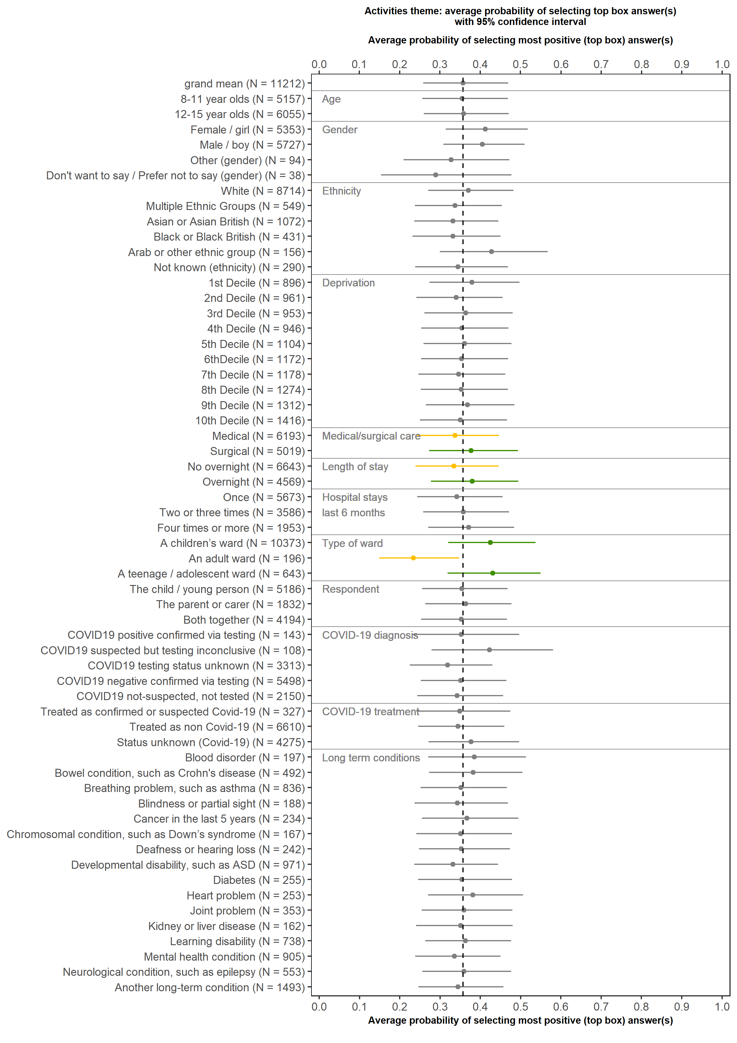
Children and young people aged 8 to 15: Activities
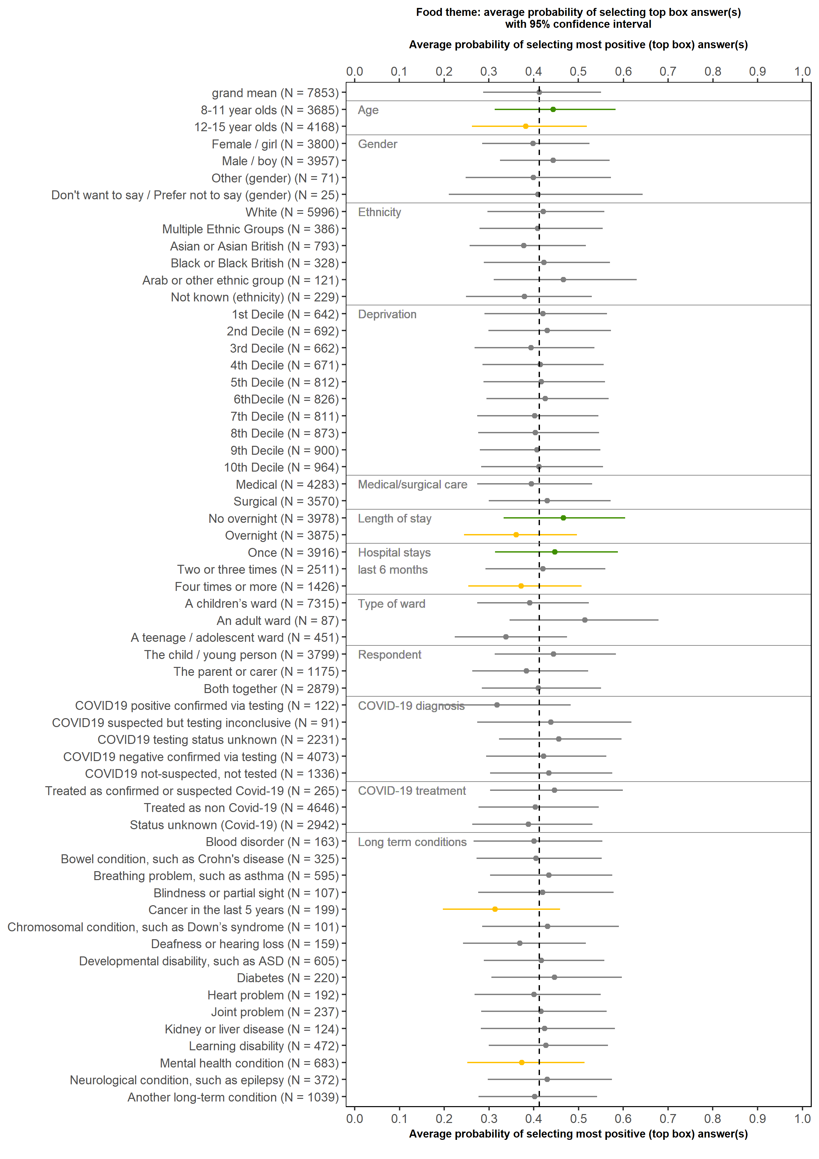
Children and young people aged 8 to 15: Food
Children and young people aged 8 to 15: Information and communication
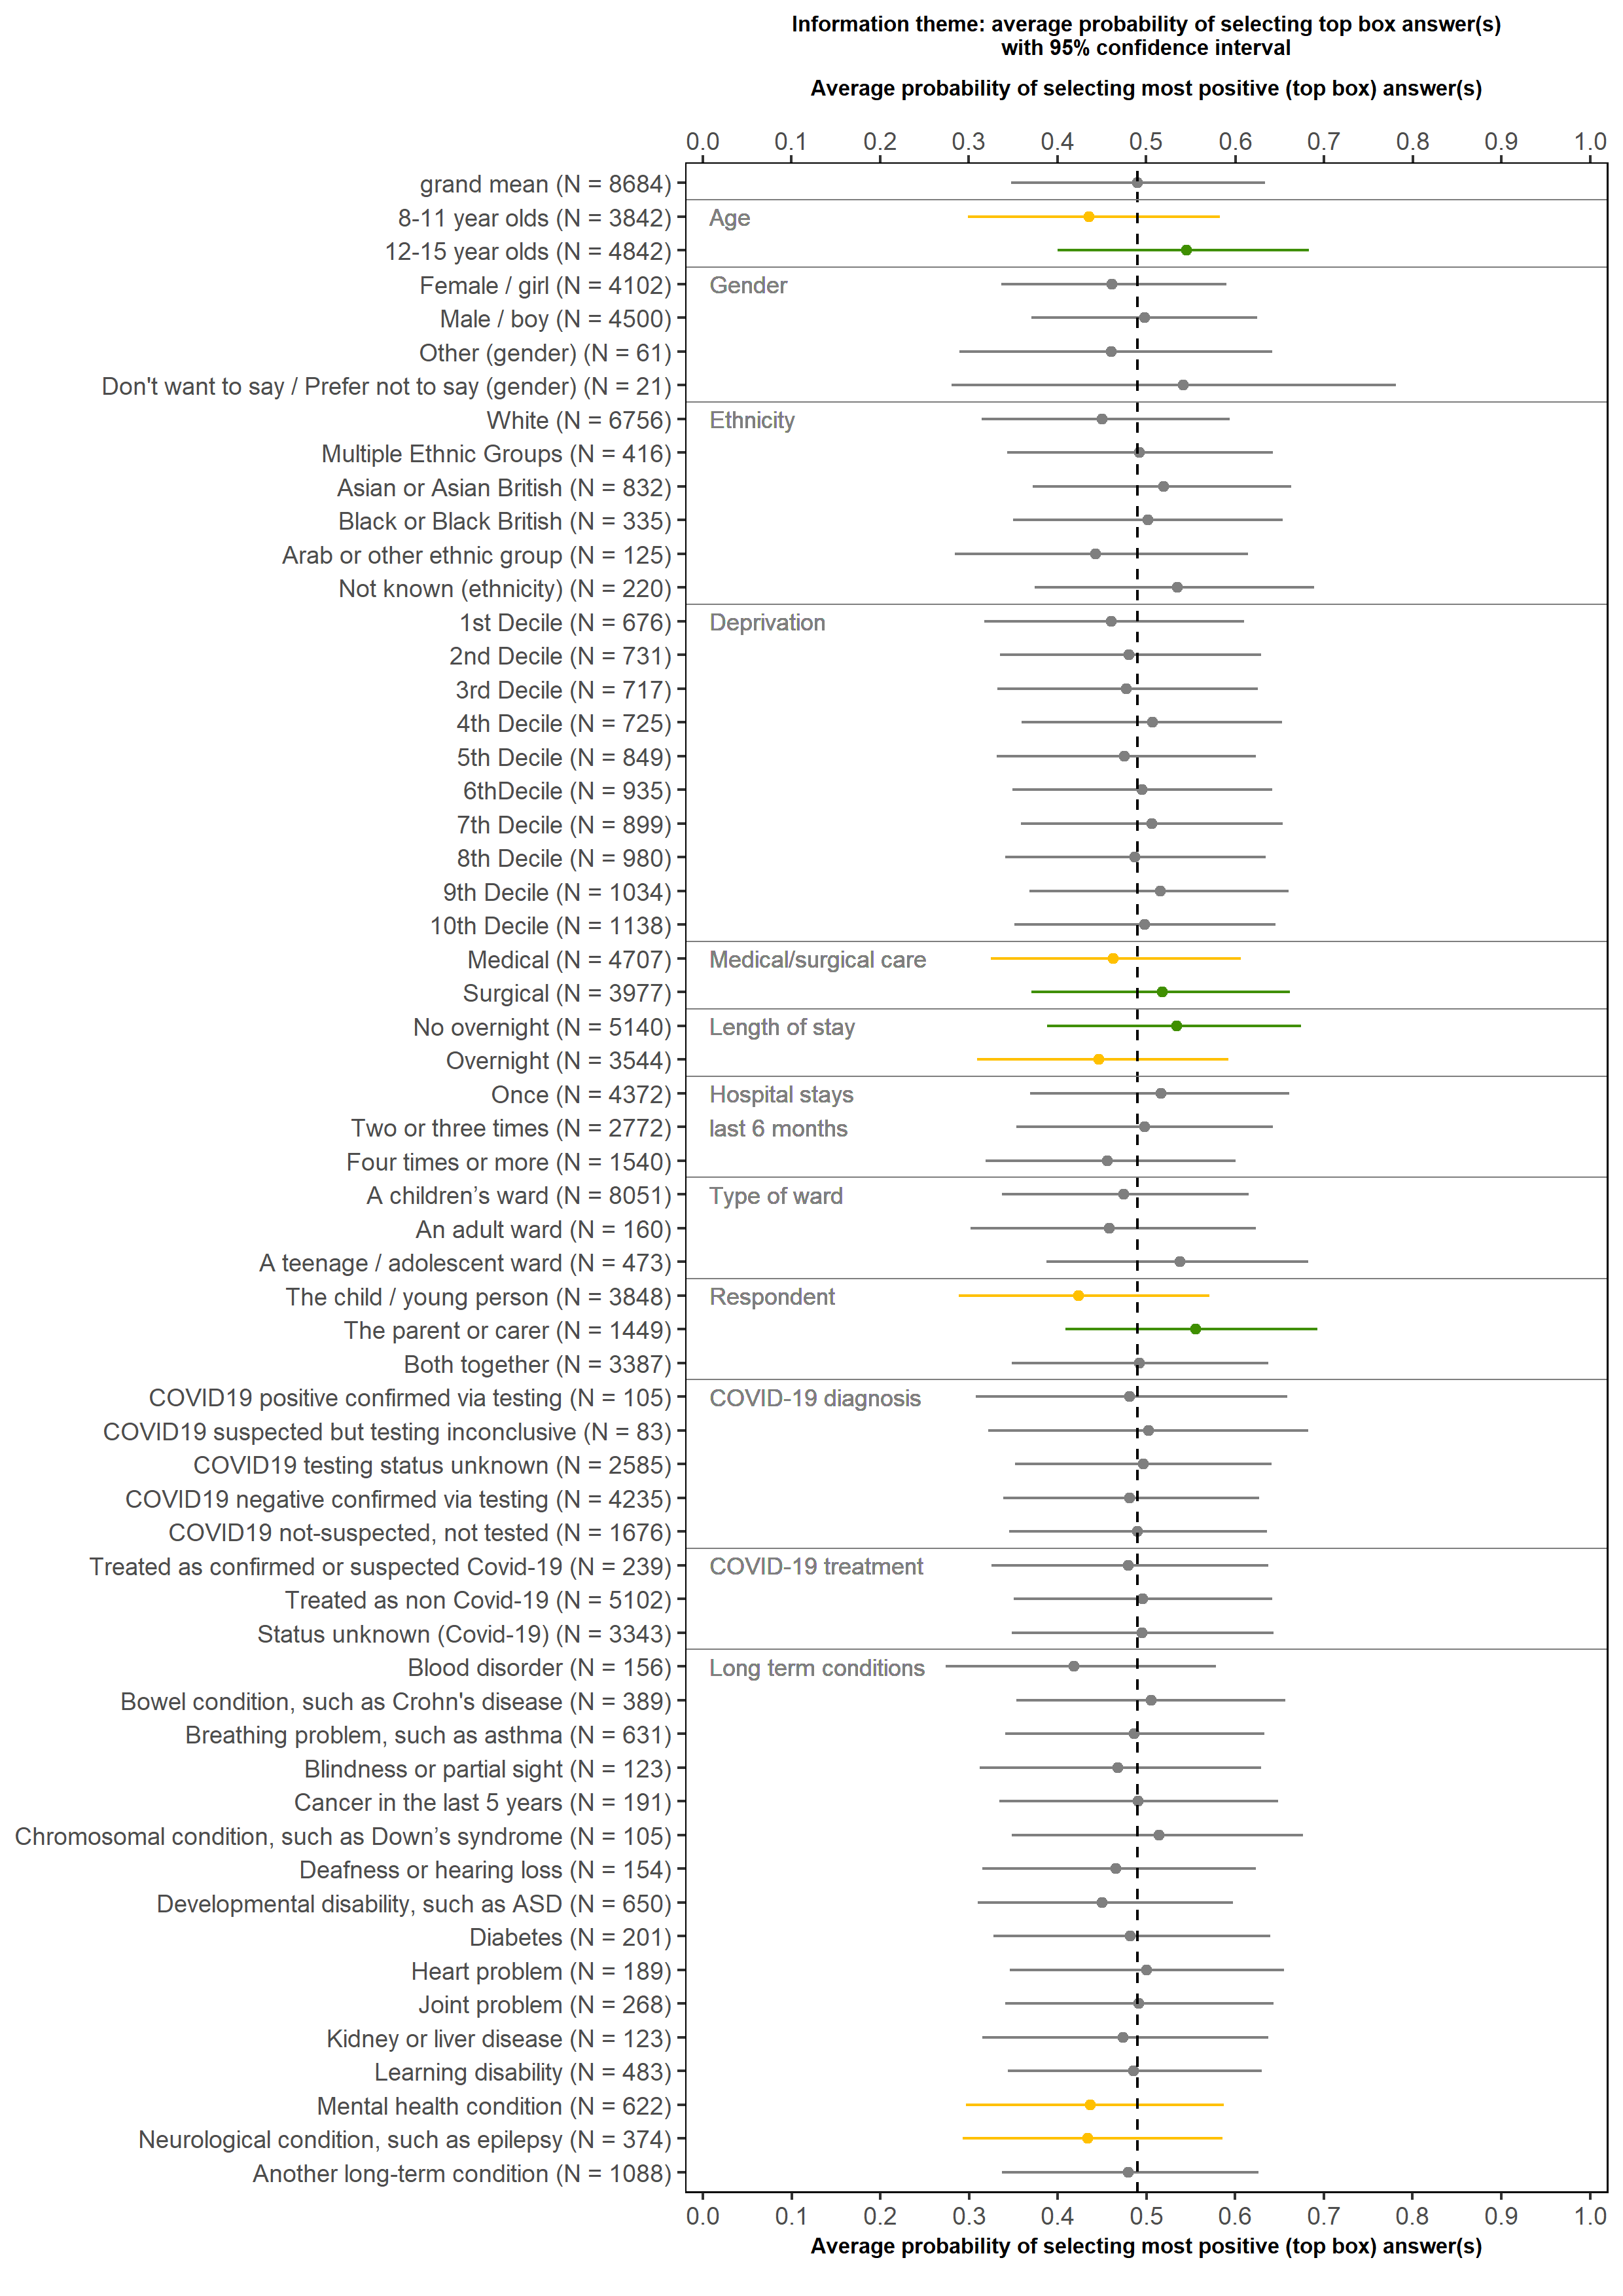
Children and young people aged 8 to 15: Respect for patient centred values, preferences and expressed needs
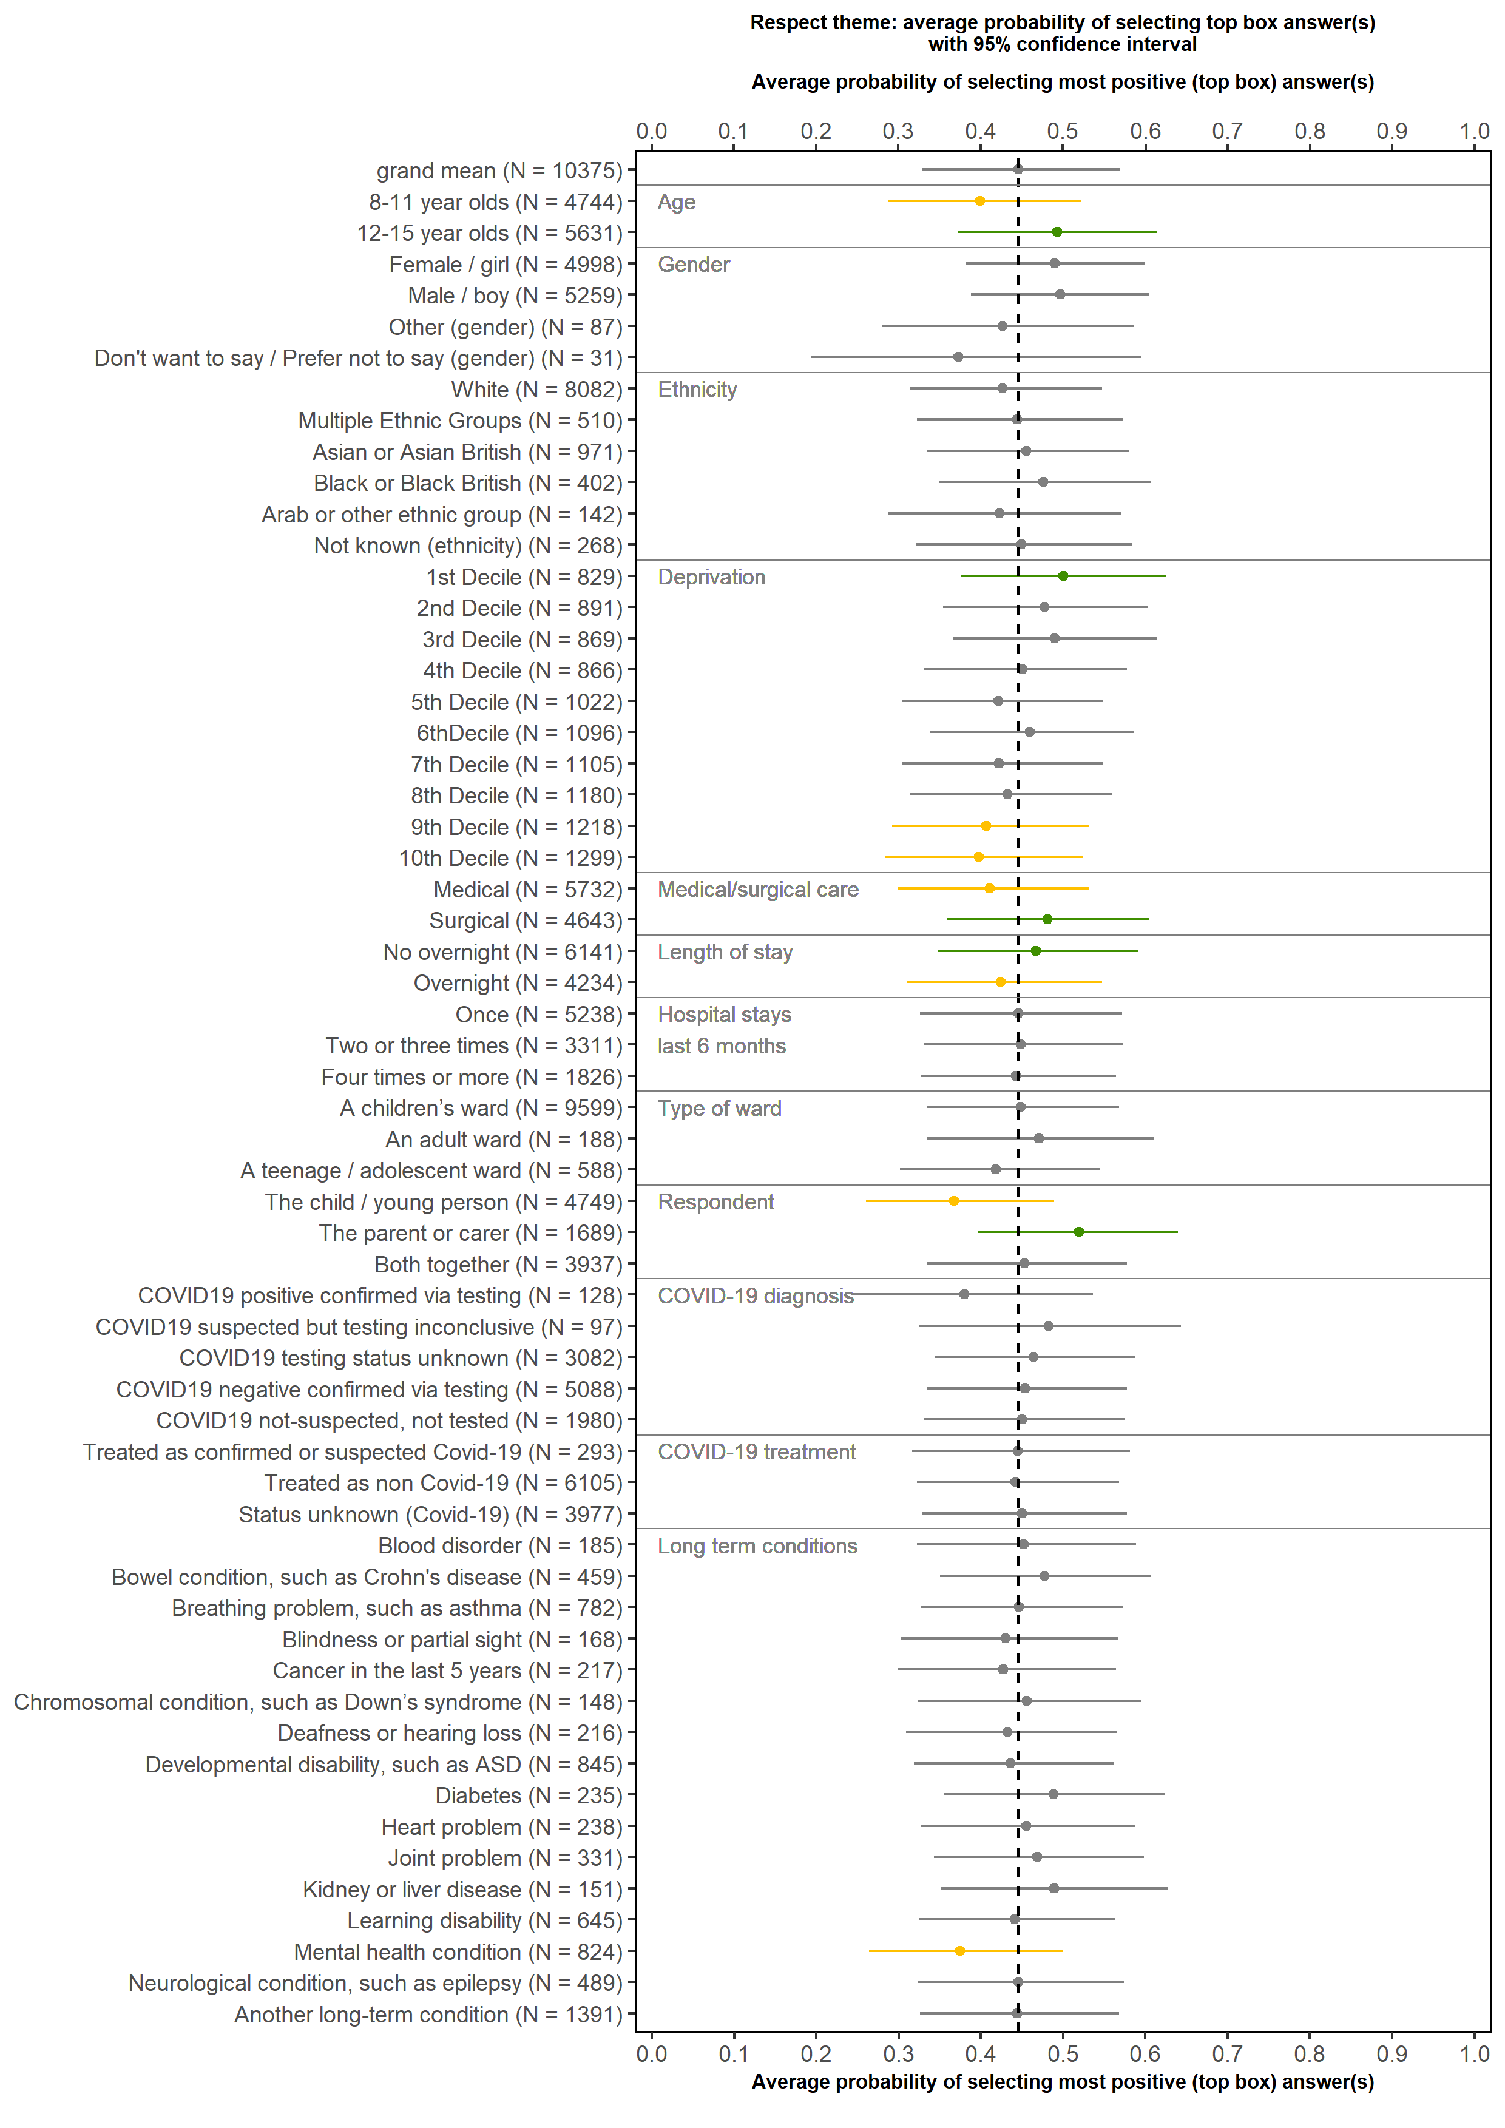
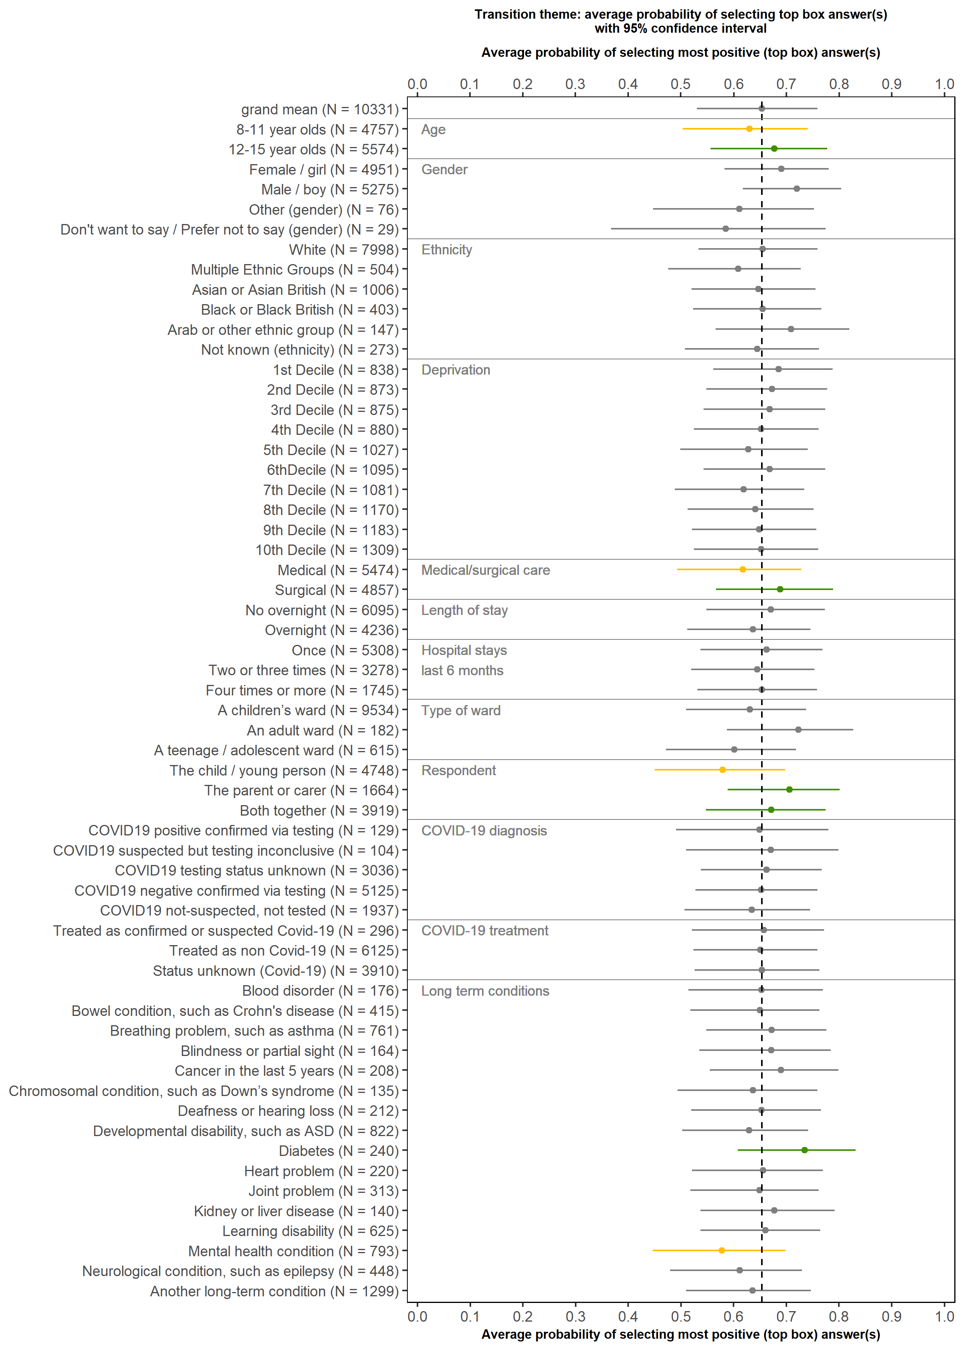
Children and young people aged 8 to 15: Transition and continuity
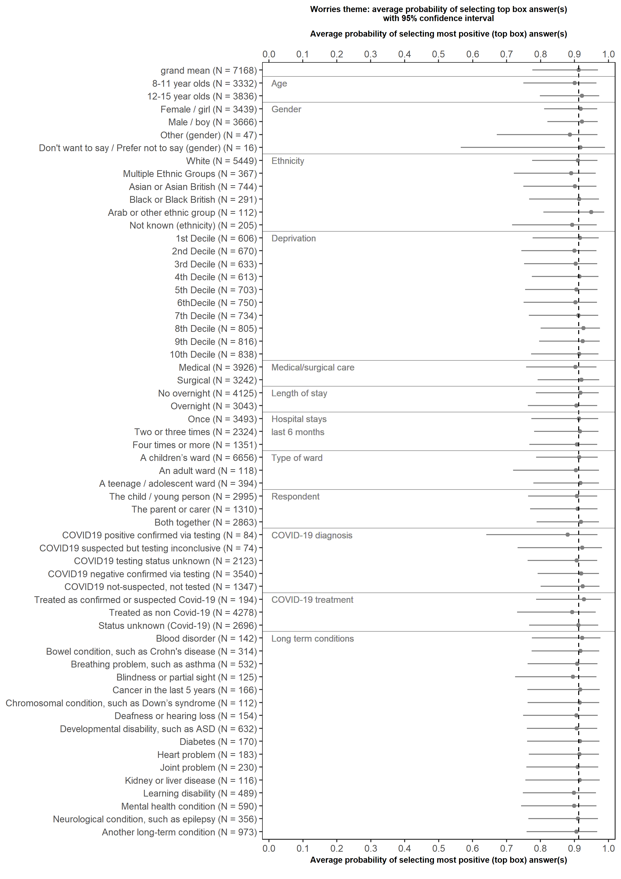
Children and young people aged 8 to 15: Worries
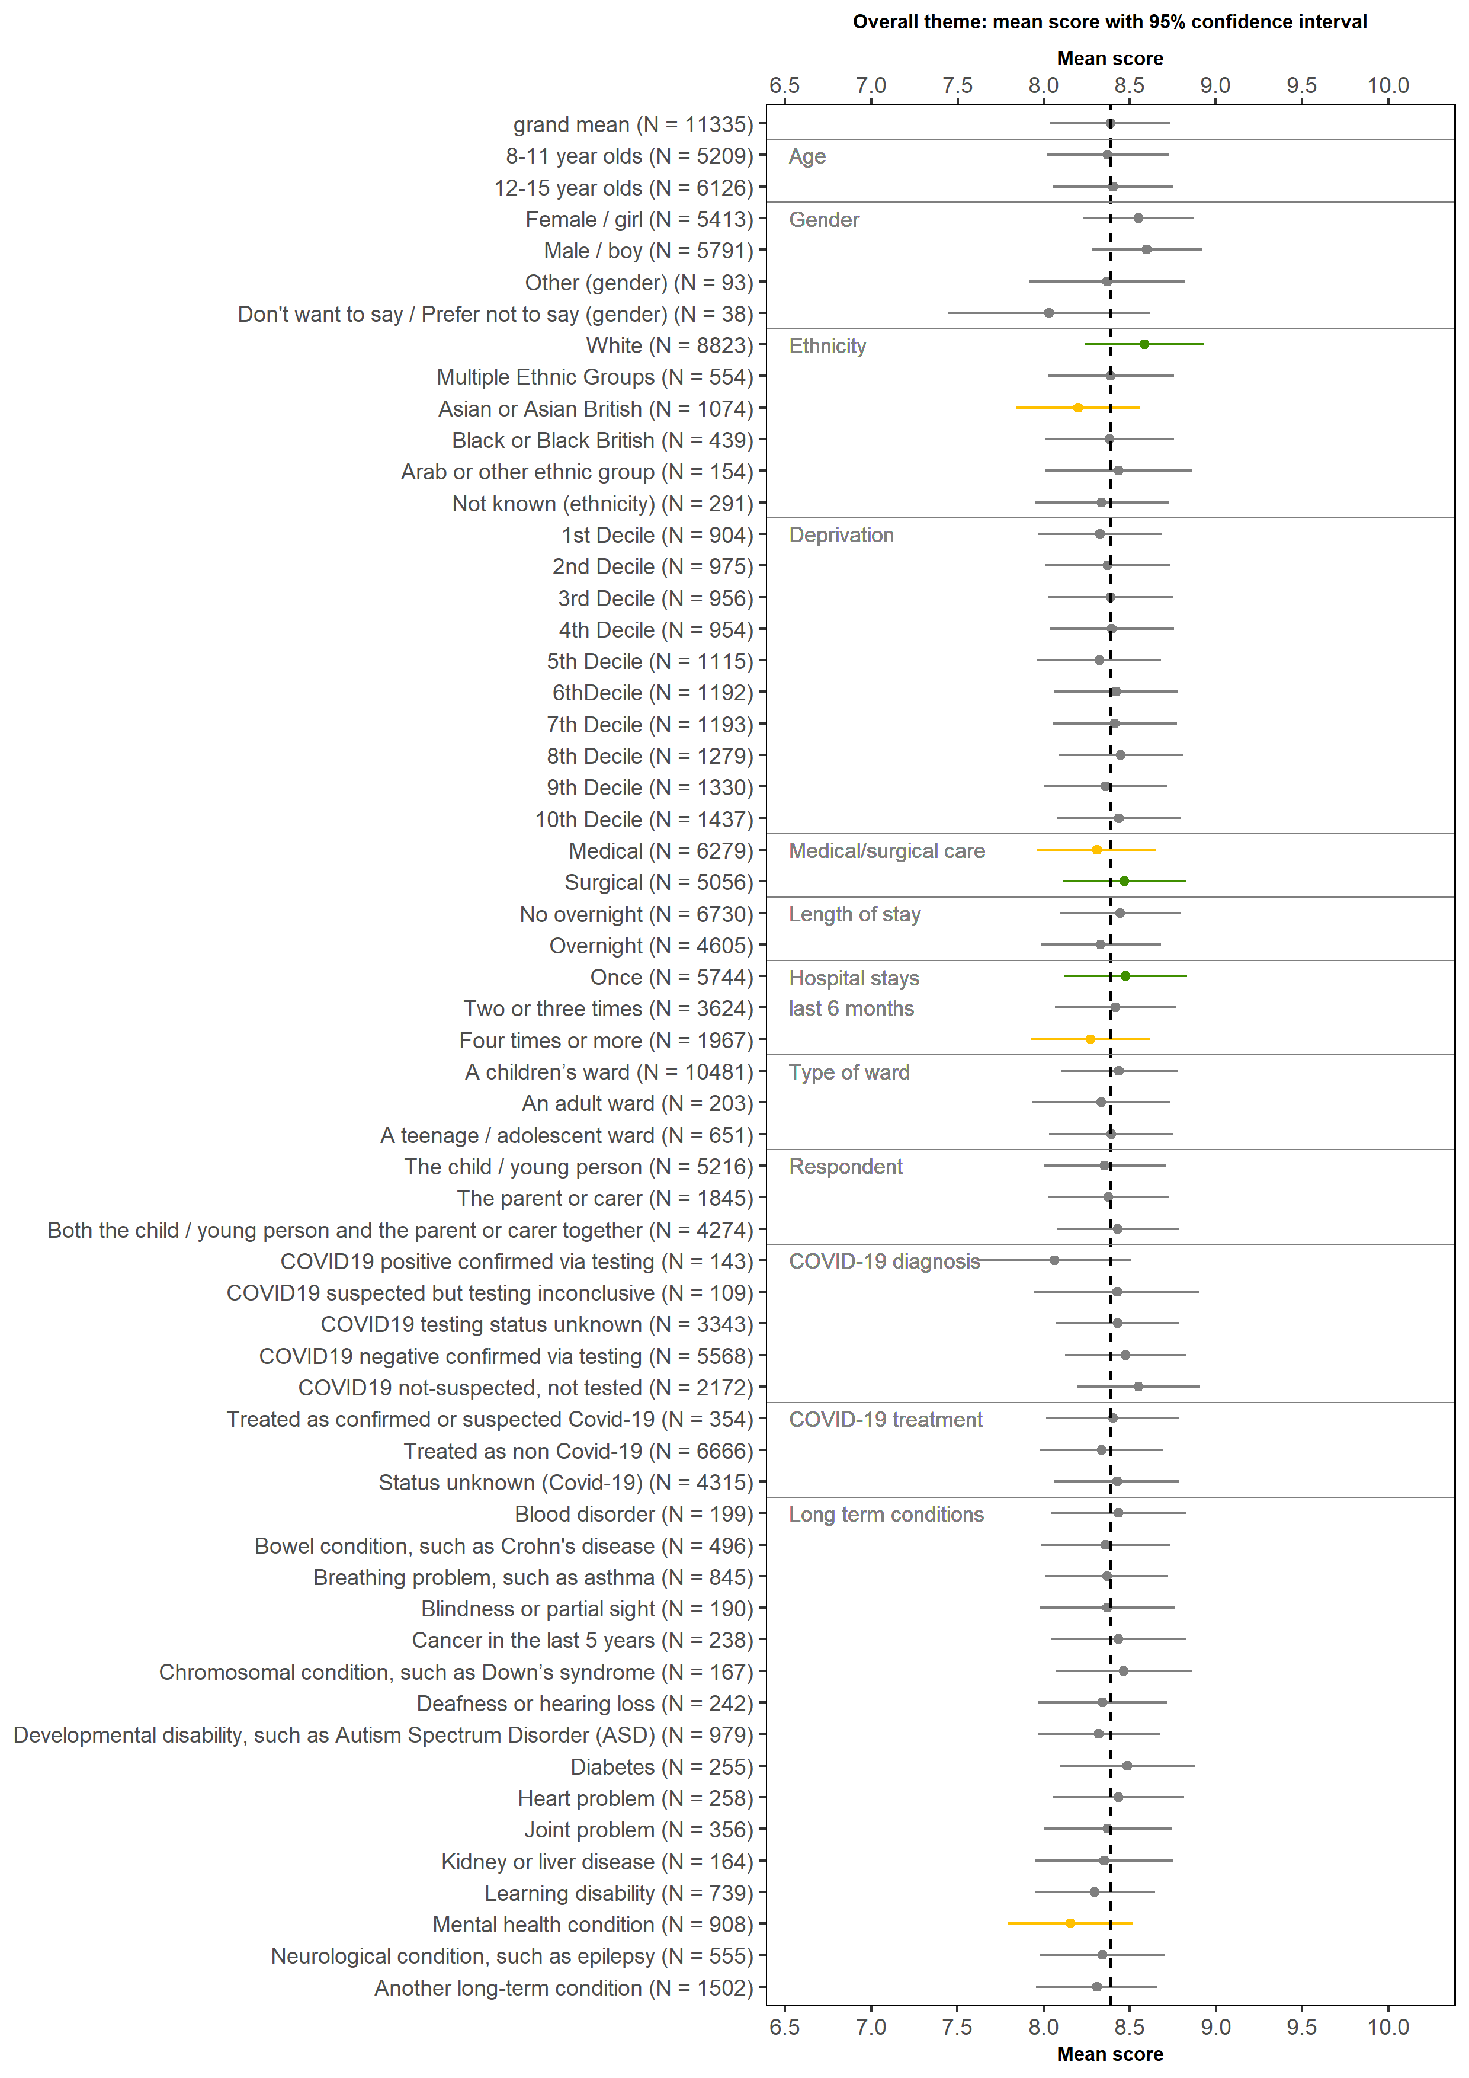
Children and young people aged 8 to 15: Overall
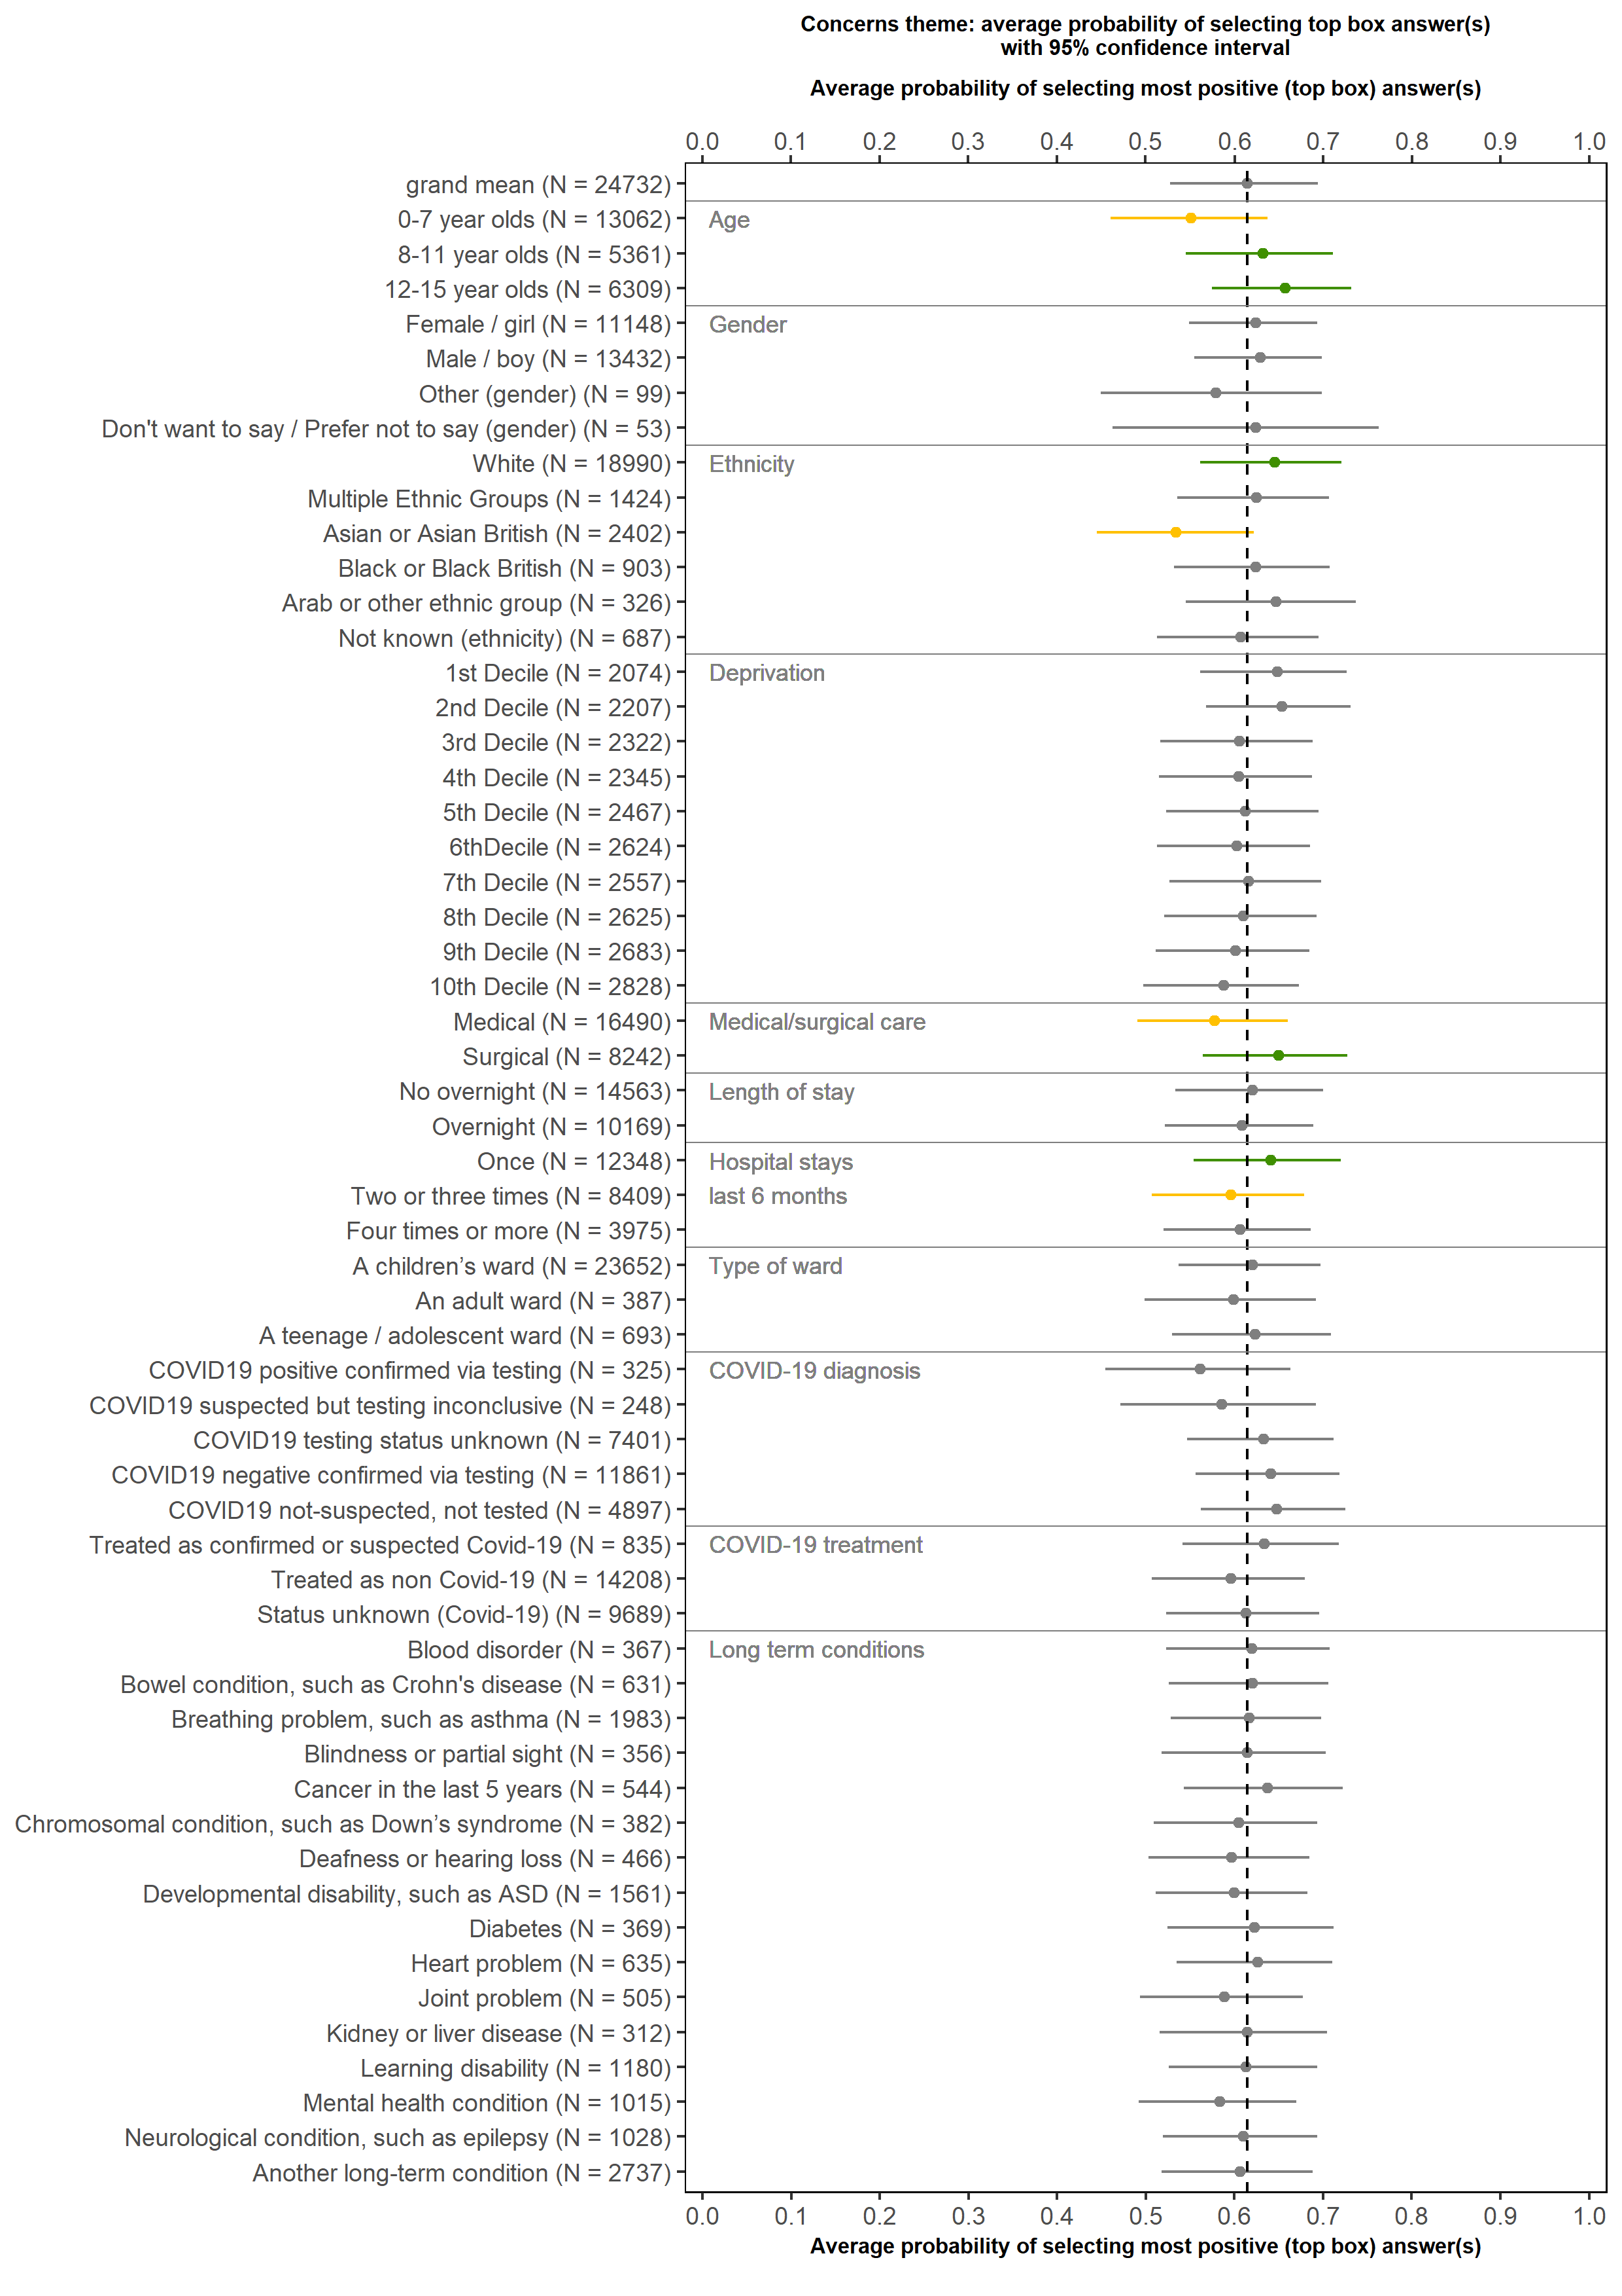
Parents and carers of children aged 0 to 15: Comfortable raising concerns
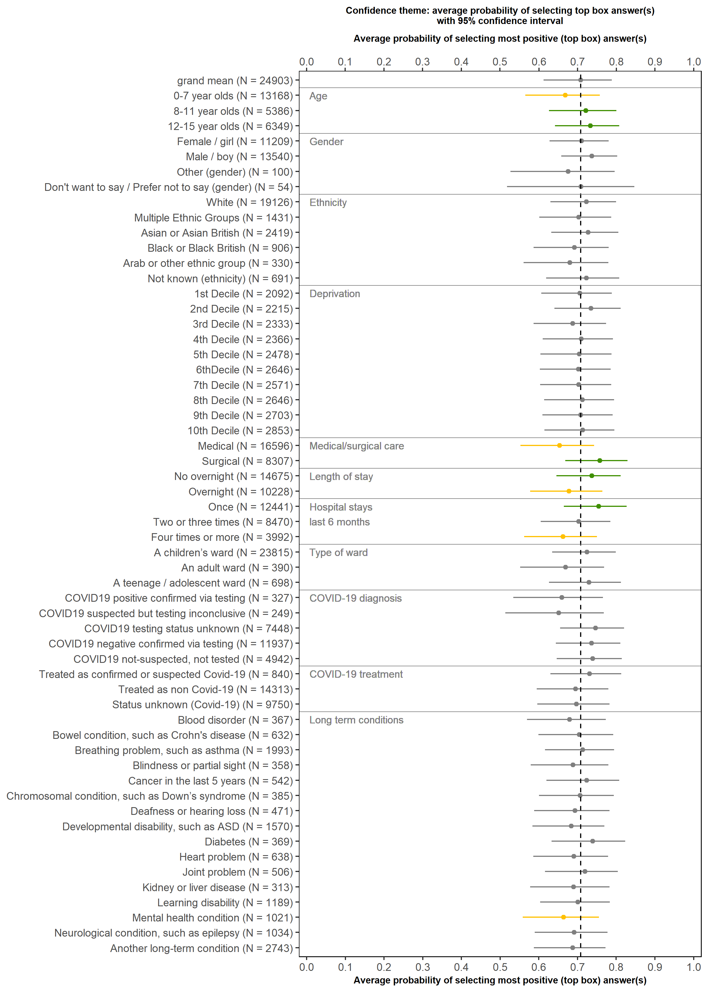
Parents and carers of children aged 0 to 15: Confidence and trust
Parents and carers of children aged 0 to 15: Parents feeling looked after
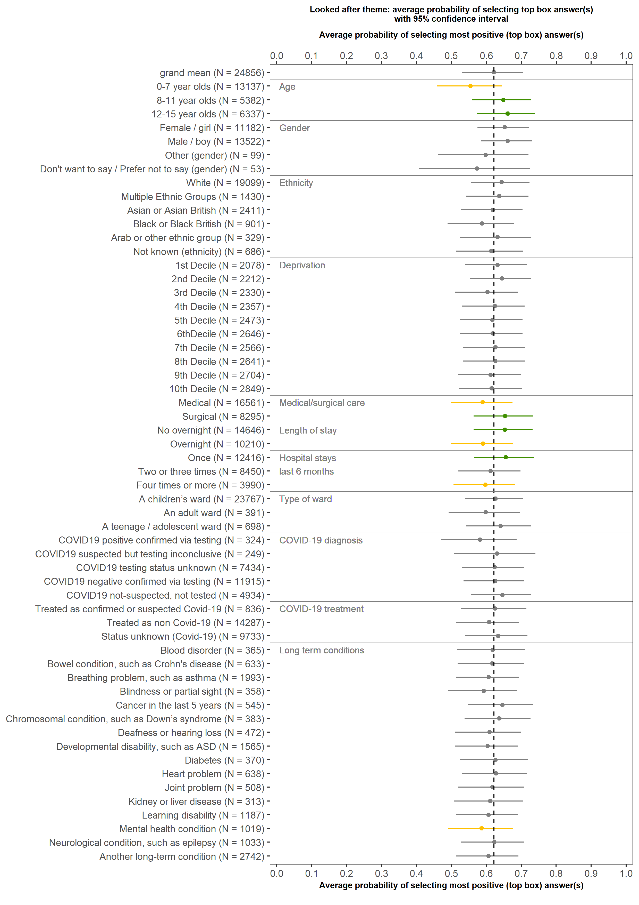
Parents and carers of children aged 0 to 15: Medical history
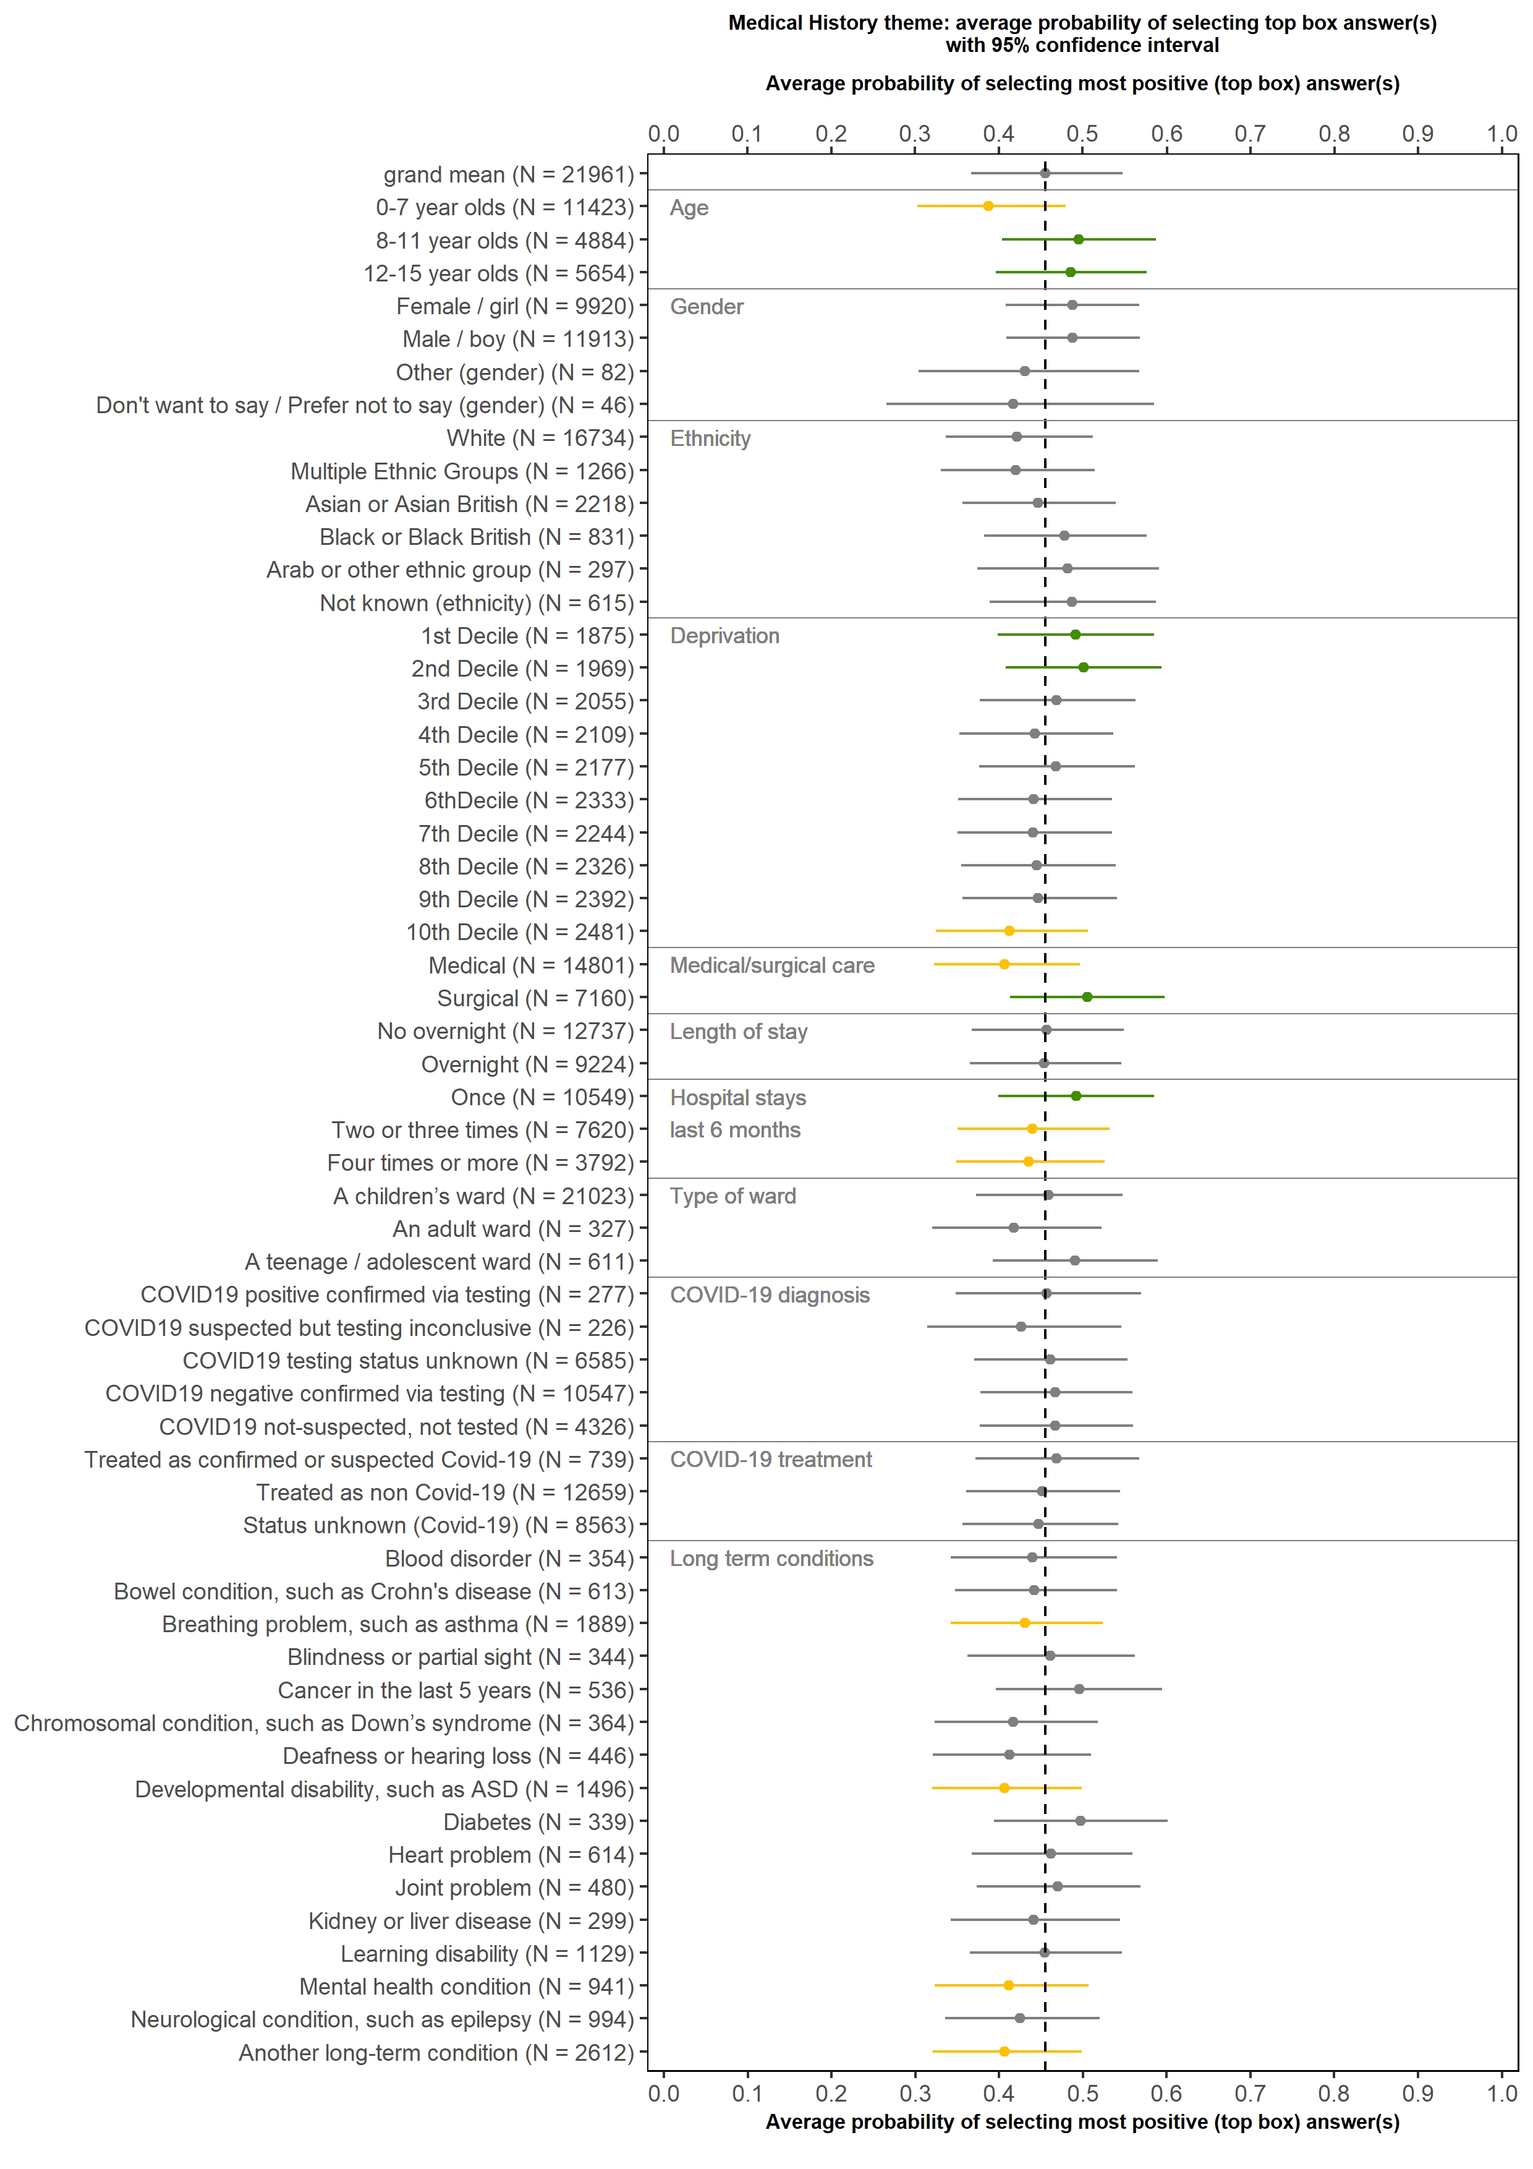

Parents and carers of children aged 0 to 15: Involvement in decisions and care
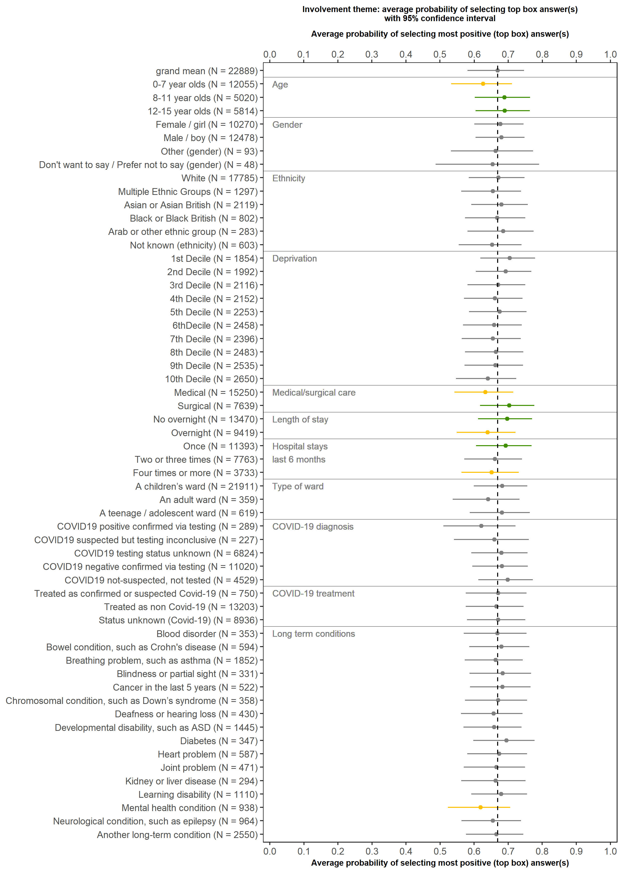
Parents and carers of children aged 0 to 15: Respect and dignity
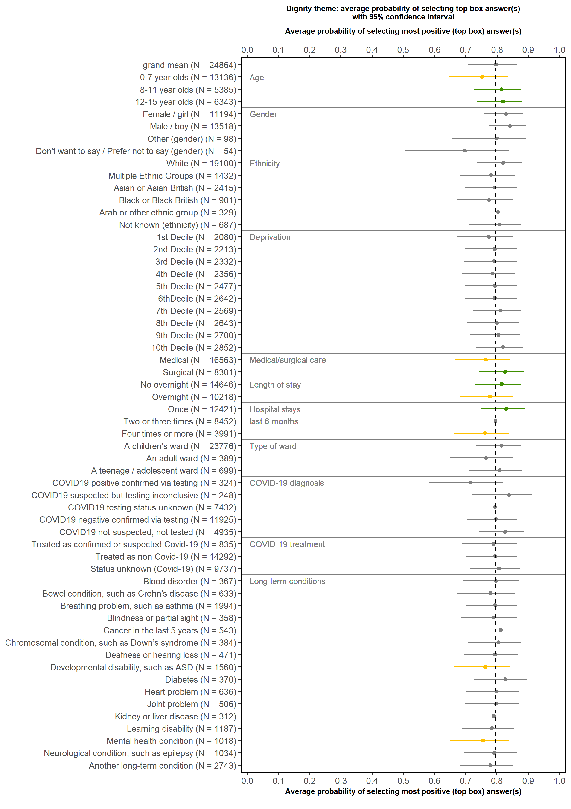

Parents and carers of children aged 0 to 15: Respect for the child’s individual needs and preferences
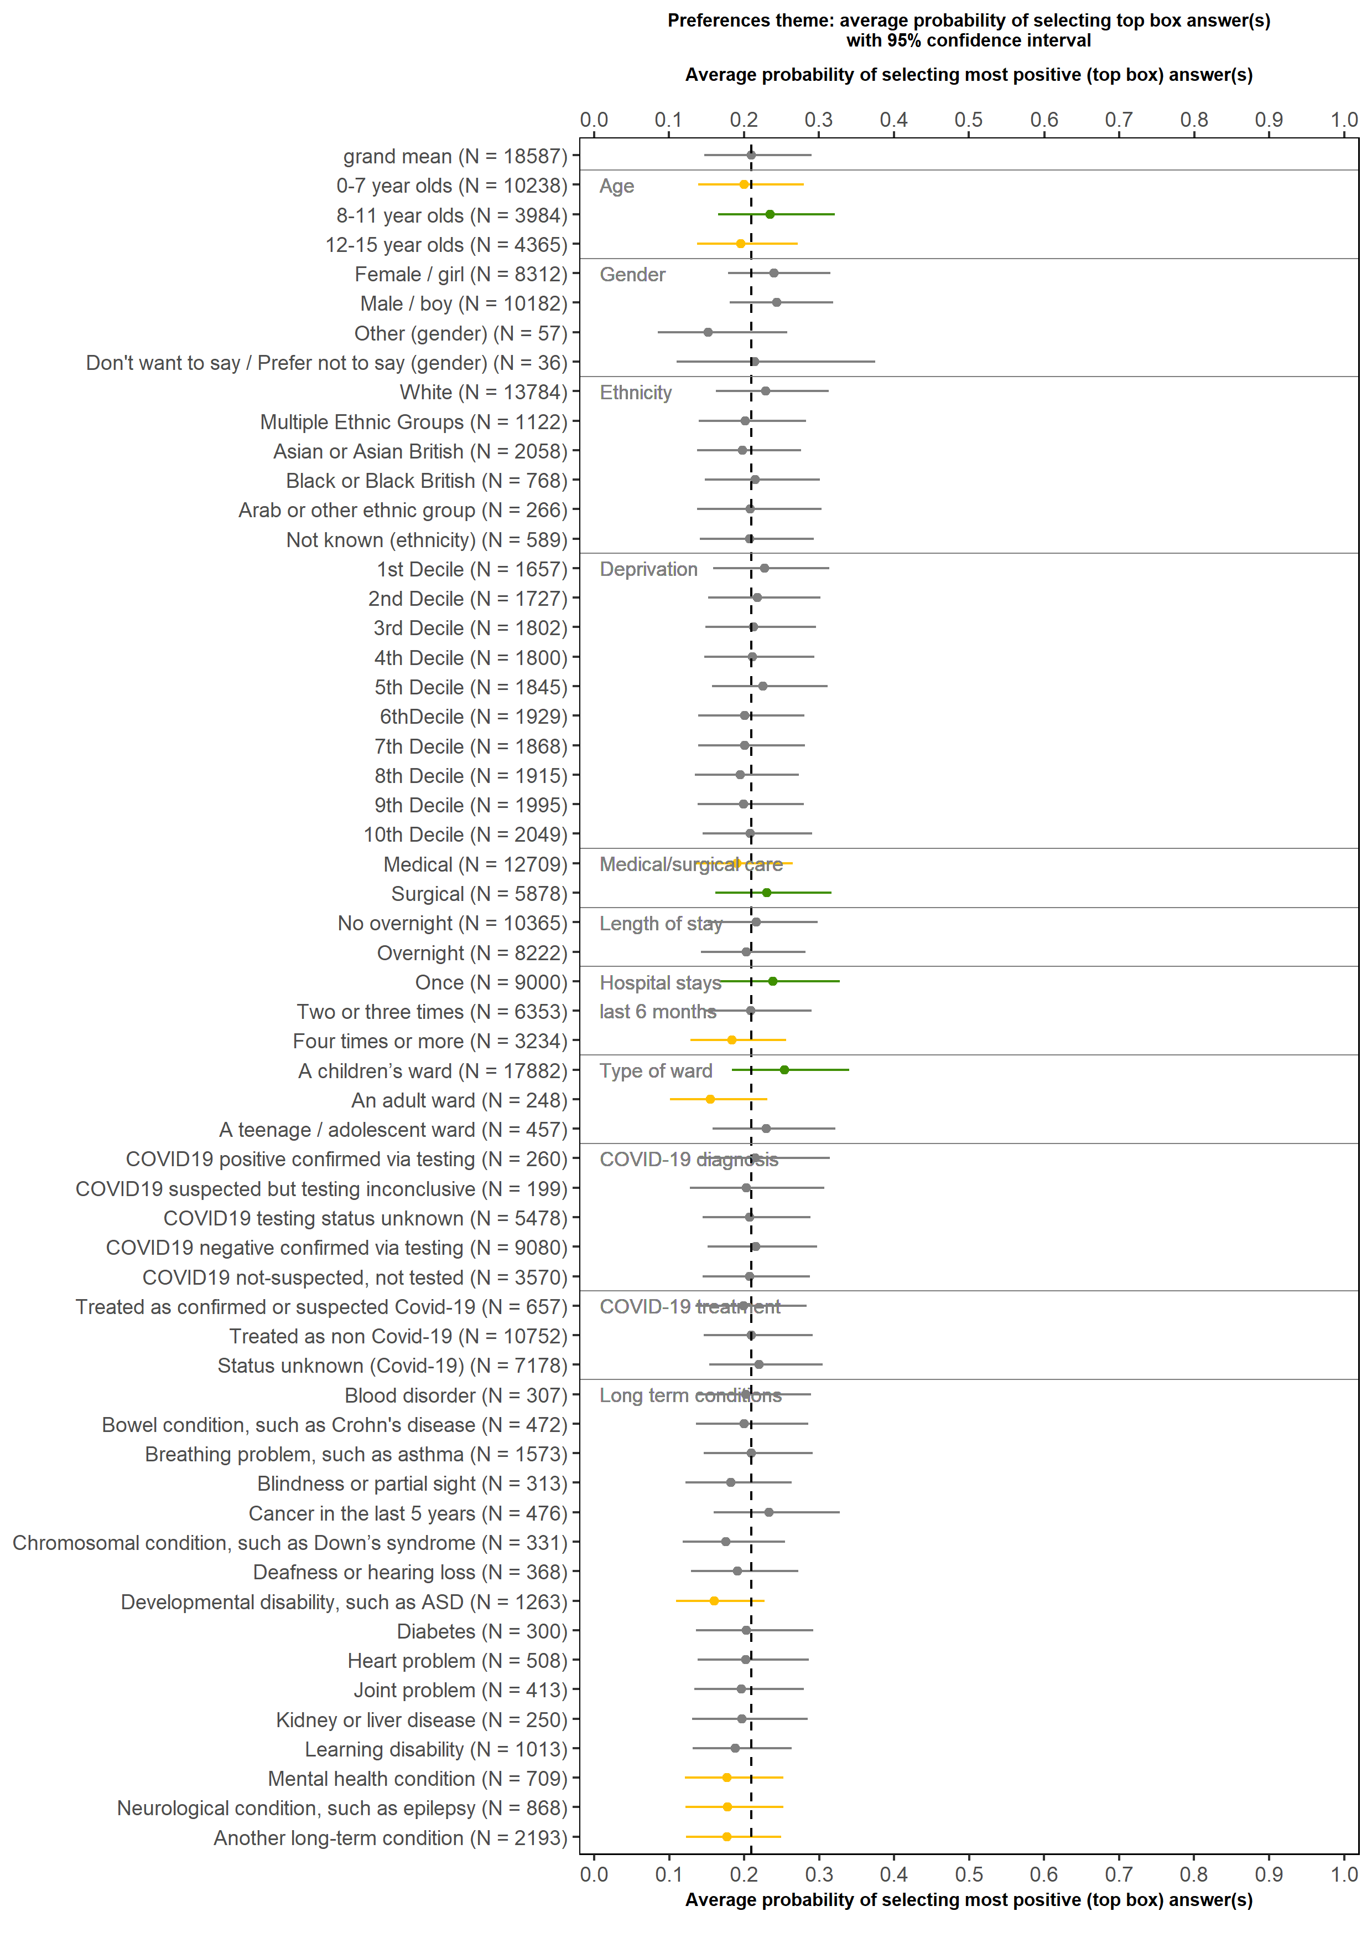
Parents and carers of children aged 0 to 15: Overall experience
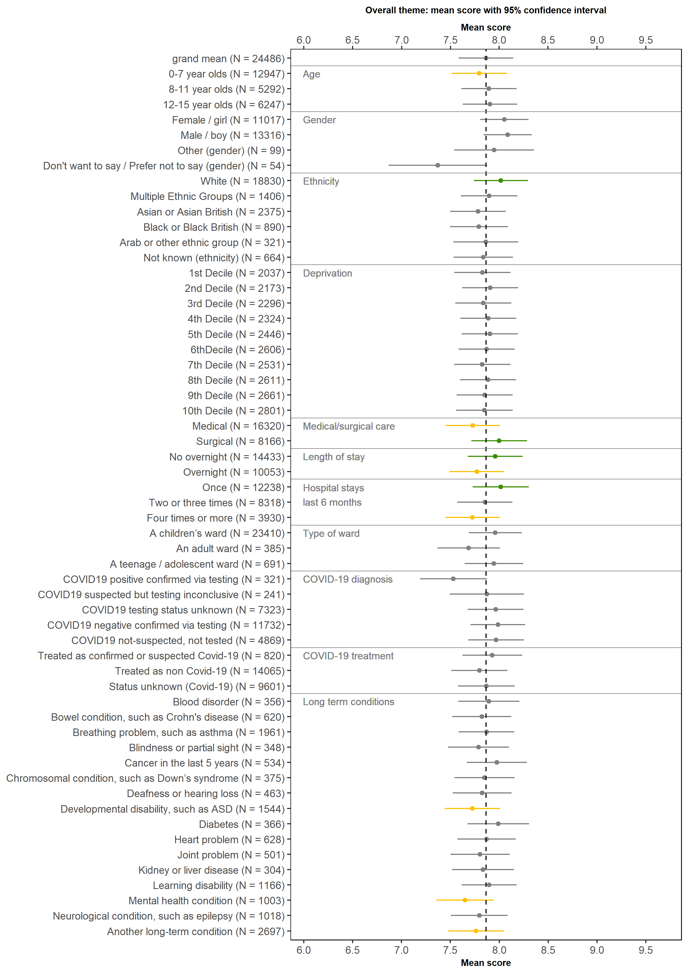

Appendix G: Demographics
The tables below show the demographic characteristics of respondents to the 2020 Children and Young People’s Patient Experience Survey, for ages 0 to 7, 8 to 11 and 12 to 15 year olds.

Does your child have any physical or mental health conditions, disabilities or illnesses that have lasted or are expected to last for 12 months or more?
 | 0-7 | 8-11 | 12-15
Yes | 26% | 37% | 43%
No | 74% | 63% | 57%
Number of respondents | 13,399 | 5,591 | 6,681
Answered by all.

Does your child have any of the following?
 | 0-7 | 8-11 | 12-15
Blood disorder | 4% | 5% | 3%
Bowel condition, such as Crohn’s disease | 3% | 8% | 11%
Breathing problem, such as asthma | 30% | 18% | 16%
Blindness or partial sight | 4% | 5% | 3%
Cancer in the last 5 years | 8% | 7% | 4%
Chromosomal condition, such as Down’s syndrome | 6% | 5% | 3%
Deafness or hearing loss | 6% | 6% | 4%
Developmental disability, such as Autism Spectrum Disorder (ASD) | 15% | 23% | 19%
Diabetes | 3% | 6% | 5%
Heart problem | 10% | 6% | 5%
Joint problem | 4% | 7% | 8%
Kidney or liver disease | 4% | 4% | 3%
Learning disability | 12% | 19% | 13%
Mental health condition | 2% | 7% | 27%
Neurological condition, such as epilepsy | 12% | 15% | 10%
Another long-term condition | 32% | 33% | 29%
Number of respondents | 3,964 | 2,359 | 3,228
Answered by respondents who reported their CYP had a long-term condition.
Multiple response question.

Do any of these reduce your child’s ability to carry out day-to-day activities?
 | 0-7 | 8-11 | 12-15
Yes, a lot | 23% | 31% | 31%
Yes, a little | 36% | 44% | 48%
No, not at all | 40% | 26% | 21%
Number of respondents | 3,928 | 2,333 | 3,207
Answered by respondents who reported their CYP had a long-term condition.

Sex by response or from sample if missing response (0-11 year olds)
 | 0-7 | 8-11
Female/girl | 43% | 45%
Male/boy | 57% | 55%
A gender not listed here/something else | 0% | 0%
Prefer not to say/don’t want to say | 0% | 0%
Non-binary | 0% | 0%
Number of respondents | 14,113 | 6,040
Answered by parents of 0 to 7 year olds and children 8 to 11 years - response data and sample data (if response is missing).

Sex by response or from sample if missing response (12-15 year olds)
 | 12-15
Female | 51%
Male | 47%
Non-binary | 1%
A gender not listed here | 0%
Unsure how to describe myself | 0%
Prefer not to say/don’t want to say | 0%
Number of respondents | 7,221
Answered by young people aged 12-15 years - response data and sample data (if response is missing).

Age group
0-7 year olds | 52%
8-11 year olds | 22%
12-15 year olds | 26%
Number of respondents | 27,374
Sample data.

Ethnic group
 | 0-7 | 8-11 | 12-15
White | 78% | 78% | 81%
Multiple ethnic group | 7% | 5% | 6%
Asian or Asian British | 11% | 11% | 9%
Black or Black British | 4% | 4% | 4%
Arab or other ethnic group | 1% | 1% | 1%
Number of respondents | 13,612 | 5,712 | 6,905
Answered by all - response data.

References

‘Adjusted’ response rate is calculated following data cleaning
Four trusts were permitted to sample patients discharged in October 2020 because they had fewer than 450 patients discharged between November 2020 and January 2021
This information can be found in the State of Care 2020/21 data appendix.
A statistically significant difference means it is very unlikely we would have obtained this result if there was no real difference.
Four trusts were permitted to sample patients discharged in October 2020 due to a low number of eligible patients discharged between November 2020 and January 2021.
Principal Treatment Centres are the specialist hospitals which coordinate the child’s treatment plan
Doyle, C., Lennox, L., & Bell, D. (2013). A systematic review of evidence on the links between patient experience and clinical safety and effectiveness. BMJ Open, 3:e001570. doi: 10.1136/bmjopen-2012-001570
Care Quality Commission A new strategy for the changing world of health and social care, 2021 https://www.cqc.org.uk/about-us/our-strategy-plans/new-strategy-changing-world-health-social-care-cqcs-strategy-2021
Care Quality Commission, State of health care and adult social care in England 2020/21, October 2020. https://www.cqc.org.uk/about-us/our-strategy-plans/new-strategy-changing-world-health-social-care-cqcs-strategy-2021
Royal College of Paediatrics and Child Health, Paediatrics 2040. https://paediatrics2040.rcpch.ac.uk/
The Kings Fund, Integrated care systems explained: making sense of systems, places and neighbourhoods, May 2021 https://www.kingsfund.org.uk/publications/integrated-care-systems-explained#what-are-ICSs
NHS England, Healthy Children: Transforming Child Health Information. November 2016 https://www.england.nhs.uk/wp-content/uploads/2016/11/healthy-children-transforming-child-health-info.pdf
Programme for Integrated Child Health website (accessed October 2021) http://pich.org.uk/
South East Strategic Clinical Networks, Transition of Children And Young People To Adult Services. June 2015. http://www.yhscn.nhs.uk/media/PDFs/Y%20and%20H%20Transition%20Toolkit/TPR%203B%20Transition%20Guides%20and%20Models/Transition_doc_full_report_FINAL.PDF
Department of Health, National Framework for Children and Young People’s Continuing Care. January 2016. https://assets.publishing.service.gov.uk/government/uploads/system/uploads/attachment_data/file/499611/children_s_continuing_care_Fe_16.pdf
National Institute for Health and Care Excellence, Transition from children’s to adults’ services for young people using health or social care services. February 2016. https://www.nice.org.uk/guidance/ng43
Royal College of Paediatrics and Child Health, Impact of COVID-19 on child health services between November 2020 and February 2021 – report, June 2021. https://www.rcpch.ac.uk/sites/default/files/managed-pdf/RCPCH-Impact-COVID-19-services-phase-2-report.pdf
Davison, G., Kelly, MA.. Conn, R., et al. (2021) How do children and adolescents experience healthcare professionals? Scoping review and interpretive synthesis. BMJ Open 2021;11:e054368. doi: 10.1136/bmjopen-2021-054368
National Children’s Bureau, Children, Young People and Health Participation, 2016. https://www.ncb.org.uk/sites/default/files/field/attachment/cyp_health_participation_final.pdf
Public Health England, COVID-19: Guidance for maintaining services within health and care settings. June 2021. https://assets.publishing.service.gov.uk/government/uploads/system/uploads/attachment_data/file/990923/20210602_Infection_Prevention_and_Control_Guidance_for_maintaining_services_with_H_and_C_settings__1_.pdf
Department of Health and Social Care et al. COVID-19: Guidance for the remobilisation of services within health and care settings: Infection prevention and control recommendations. August 2020. https://assets.publishing.service.gov.uk/government/uploads/system/uploads/attachment_data/file/910885/COVID-19_Infection_prevention_and_control_guidance_FINAL_PDF_20082020.pdf
Royal College of Paediatrics and Child Health, COVID-19 - guidance for management of children admitted to hospital, April 2020. https://www.rcpch.ac.uk/resources/covid-19-guidance-management-children-admitted-hospital
World Health Organisation, Standards for improving the quality of care for children and young adolescents in health facilities, 2018. https://apps.who.int/iris/bitstream/handle/10665/272346/9789241565554-eng.pdf?ua=1
Starlight, The Impact of Children’s Play in Hospital, October 2020 https://www.starlight.org.uk/wp-content/uploads/2020/10/Starlight_ImpactOfPlay_Report_Oct20.pdf
Great Ormond Street Hospital, Coronavirus (COVID-19) – information for children, young people and families, January 2021 https://www.gosh.nhs.uk/news/coronavirus-covid-19-information-children-young-people-and-families/
Care Quality Commission, State of health care and adult social care in England 2019/20, October 2020. https://www.cqc.org.uk/sites/default/files/20201016_stateofcare1920_fullreport.pdf
Royal College of Paediatrics and Child Health, The impact of COVID-19 on child health services – report, May 2020. https://www.rcpch.ac.uk/sites/default/files/managed-pdf/Impact%20-of-COVID-19-child-health-services-web.pdf.pdf
Royal College of Paediatrics and Child Health, Impact of COVID-19 on child health services between November 2020 and February 2021 – report, June 2021. https://www.rcpch.ac.uk/sites/default/files/managed-pdf/RCPCH-Impact-COVID-19-services-phase-2-report.pdf
NHS Digital, Provisional Monthly Hospital Episode Statistics for Admitted Patient Care and Outpatient data April 2020, August 2020 https://digital.nhs.uk/data-and-information/publications/statistical/hospital-episode-statistics-for-admitted-patient-care-outpatient-and-accident-and-emergency-data/april-2020---august-2020
Royal College of Paediatrics and Child Health, National guidance for the recovery of elective surgery in children, July 2020. https://www.rcpch.ac.uk/sites/default/files/generated-pdf/document/National-guidance-for-the-recovery-of-elective-surgery-in-children.pdf
NHS Digital, Provisional Monthly Hospital Episode Statistics for Admitted Patient Care and Outpatient data June 2021, June 2021 https://digital.nhs.uk/data-and-information/publications/statistical/hospital-episode-statistics-for-admitted-patient-care-outpatient-and-accident-and-emergency-data/april-2021---june-2021
Department for Education, Ensuring a good education for children who cannot attend school because of health needs: Statutory guidance for local authorities, January 2013 https://assets.publishing.service.gov.uk/government/uploads/system/uploads/attachment_data/file/941900/health_needs_guidance_accessible.pdf
Stickland, A., Clayton, E., Hill, C. Children's sleep quality in hospital. Archives of Disease in Childhood 2012, 97(1). http://dx.doi.org/10.1136/archdischild-2012-301885.158
Royal College of Paediatrics and Child Health, Facing the Future: Together for child health, 2015. https://www.rcpch.ac.uk/sites/default/files/Facing_the_Future_Together_for_Child_Health.pdf
The Hello my name is…website (accessed October 2020) https://www.hellomynameis.org.uk/
UK Health Security Agency, Infection prevention and control for seasonal respiratory infections in health and care settings (including SARS-CoV-2) for winter 2021 to 2022, November 2021. https://www.gov.uk/government/publications/wuhan-novel-coronavirus-infection-prevention-and-control/covid-19-guidance-for-maintaining-services-within-health-and-care-settings-infection-prevention-and-control-recommendations#IPCmeasures
Koukourikos, K., Tzeha, L., Pantelidou, P., & Tsaloglidou, A. (2015). The Importance Of Play During Hospitalization Of Children. Materia socio-medica, 27(6), 438–441. https://doi.org/10.5455/msm.2015.27.438-441
Royal College of Surgeons, Standards for Children’s Surgery, 2013 https://www.rcseng.ac.uk/-/media/files/rcs/library-and-publications/non-journal-publications/rcs_standards_for_childrens_surgery_2013.pdf
The Royal College of Emergency Medicine, Management of Pain in Children. July, 2017. https://rcem.ac.uk/docs/RCEM%20Guidance/RCEM%20Pain%20in%20Childre%20n%20-%20Best%20Practice%20Guidance%20(REV%20Jul%202017).pdf
National Institute for Health and Care Excellence, Babies, children and young people's experience of healthcare, August 2021. https://www.nice.org.uk/guidance/ng204/resources/babies-children-and-young-peoples-experience-of-healthcare-pdf-66143714734789
Picker, Under 16 Cancer Patient Experience Survey 2020 Technical Appendix, October 2021 https://www.under16cancerexperiencesurvey.co.uk/sites/default/files/inline-files/P3313_U16CPES20_Technical%20Appendix_FINAL_22.10.21.pdf

